**SWE40006 – Deployment Activity 2**

**Student Details**

* **Full name:** Dang Khoa Le
* **Student ID:** 103844421
* **Due date:** 31/08/2025
* **Submission date:** 31/08/2025

**Unit Details**

* **Unit code & name:** SWE40006 – Software Deployment and Evolution
* **Semester:** Semester 2, Year 2025

**Declaration of Task Levels Attempted**

* **Task 2.1 (Pass)** – Following AWS documentation on the links provided, and complete following tasks: open an AWS account, create an SSH key pair, create an EC2 instance, deploy a WordPress application to Amazon S3.
* **Task 2.2 (Credit)** – Create an ELB, re-install WordPress using an external database, backup instance to S3, create an instance from S3 backup.
* **Task 2.3 (Distinction)** – Create a Launch Template, ASG, configure ASG to launch instance, test scaling.
* **Task 2.4 (High Distinction)** – set up and demonstrate SSH access from MacOS. This will be demonstrated through all 3 tasks 2.1 to 2.3.
* **Appendix** – Show what couldn’t be implemented and my walkarounds on AWS Learner Lab account.

**2.0 - Prerequisites**

As shown in the Appendix, my app couldn’t been deployed with CodeDeploy on Amazon S3 and creation of RDS due to the lack of IAM user, IAM role and permission attachment.

I used my personal email address for this task: [binkhoale1812@gmail.com](mailto:binkhoale1812@gmail.com).

This is because the Swinburne student email address has been registered with the AWS Learner Lab session. Most of these tasks follow the walkthroughs from Appendix section, with some minor changes are adapted since we have more permissions and accessibility on my personal AWS account.

**2.0.1 Budget**

I then have to create a personal account, in order to do this task. I began with account verifications and set a budget to ensure my app doesn’t overspent. Once my app exceed $1 of credit, then I will receive a notification to my email address.

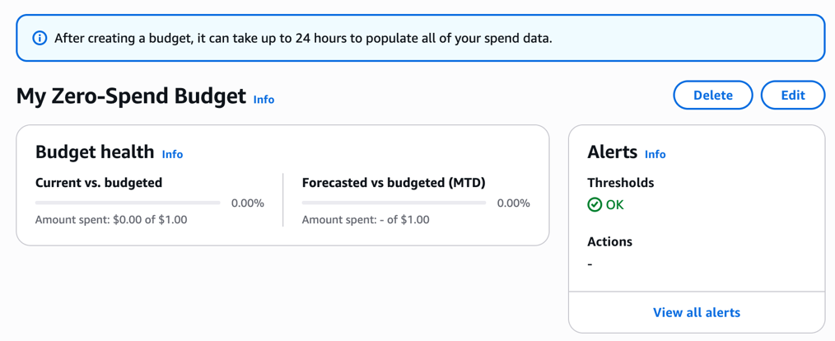

Figure. Budget setter

**2.0.2 IAM User**

I began with creating an IAM User with proper roles and permissions for this task.

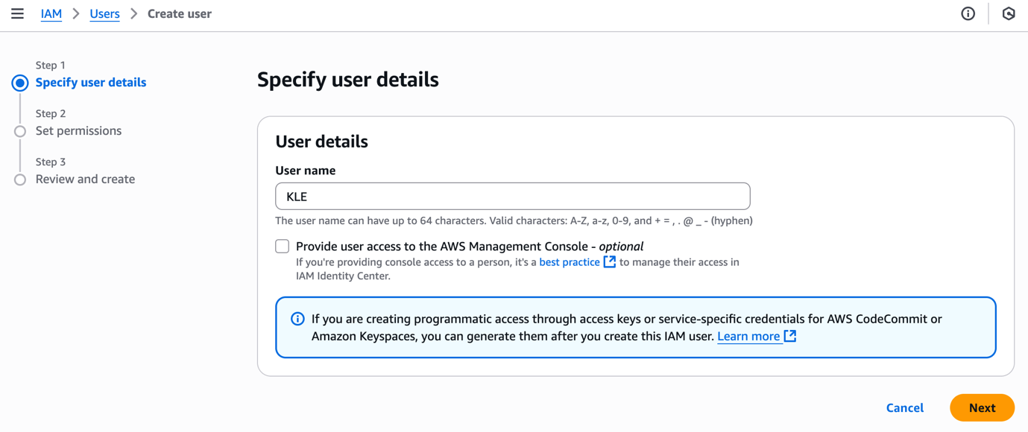

Figure. Creation of IAM User KLE

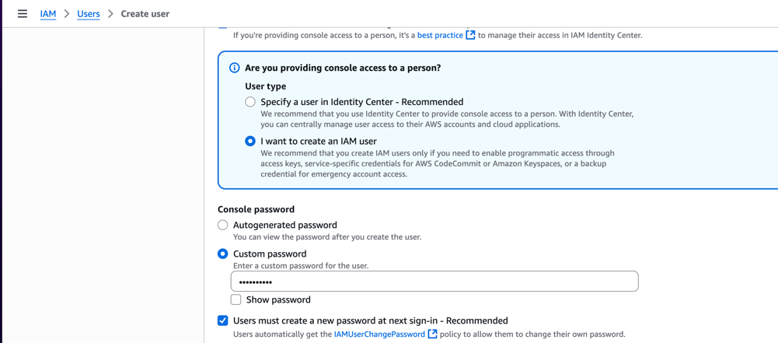

Figure. Provide user access to the AWS Management Console

Usually, for convenient, I would just attach AdministratorAccess policy directly, which show full functionalities and permission in general. However, to demonstrate **security practice** (good system governance), I would pick each of these individually (with justifications):

**For the EC2 Instance Role (WPInstanceRole)**

* *AmazonEC2RoleforAWSCodeDeploy* (lets agent talk to CodeDeploy)
* *AmazonS3ReadOnlyAccess* (to pull artifacts)
* AmazonSSMFullAccess (to use Systems Manager, and create CodeDeploy agent association)

**For the CodeDeploy Service Role (CodeDeployServiceRole)**

* service-role/AWSCodeDeployRole (managed policy — minimal required)

**For the Deployer IAM user (admin access)**

* AWSCodeDeployFullAccess
* AmazonEC2FullAccess
* ElasticLoadBalancingFullAccess
* AWSAutoScalingPlansEC2AutoScalingPolicy
* AmazonRDSFullAccess
* AmazonS3FullAccess
* CloudWatchFullAccess

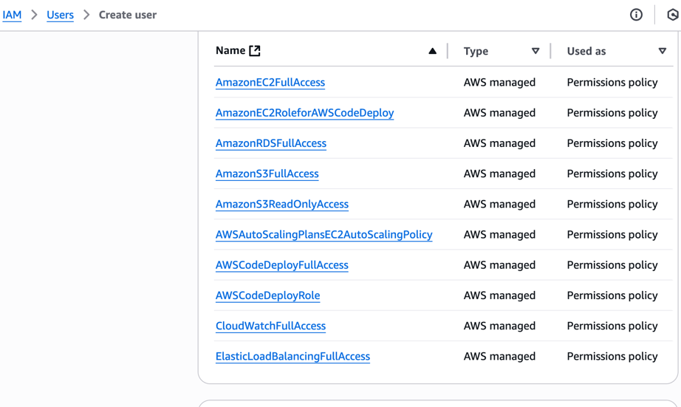

Figure. IAM permissions

For later revision, I also downloaded *KLE_credentials.csv* file on Save CSV option. Then, I need to create access key to deploy my WordPress app to S3 bucket via CLI.

Note: AmazonSSMFullAccess (or any SSM policy) exceed this account's quota as shown:

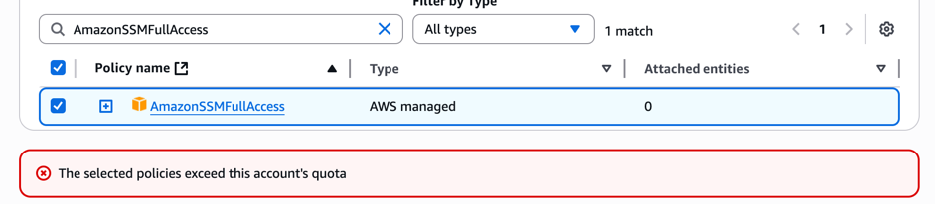

Figure. AmazonSSMFullAccess policy denial

So, we need to go other way around:

Go to IAM → Users → KLE → Permissions → Create inline policy → JSON, and edit the cell as:

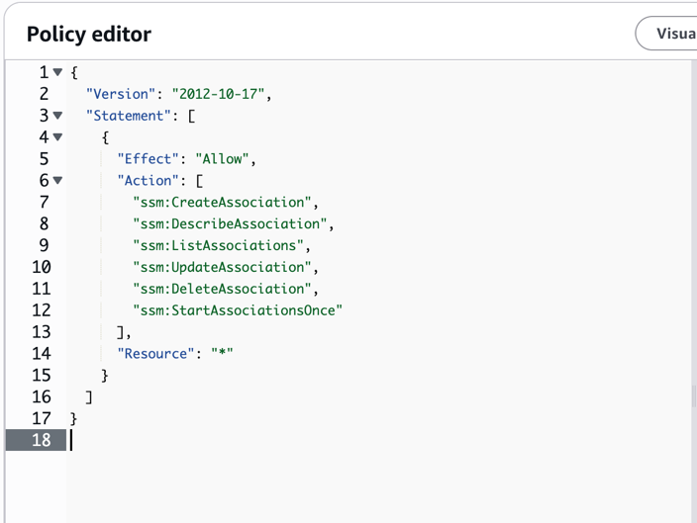

Figure. Amazon SSM inline policy JSON

This lets IAM user create and manage associations like the AWS-ConfigureAWSPackage one we tried for CodeDeploy agent.

I named this inline policy AllowSSMAssociation.

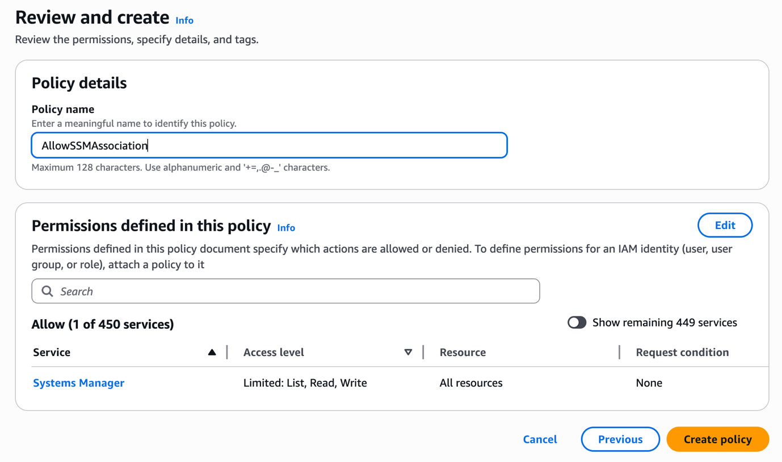

Figure. Amazon SSM inline policy review and creation

In the user page, go to the **Security credentials** tab.

* Scroll to **Access keys**.
* Click **Create access key**.
* Choose use case: select **Command Line Interface (CLI)**.
* A pair is generated:
  + Access key ID
  + Secret access key ( wecan only view this once, download .csv file or copy it).

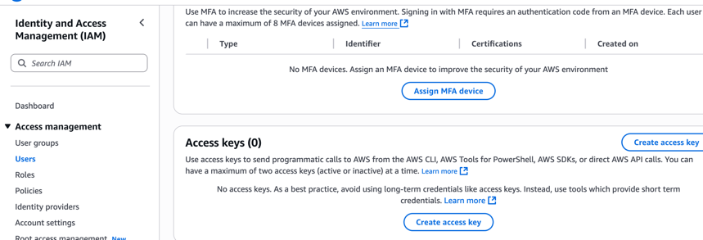

Figure. Create access key location

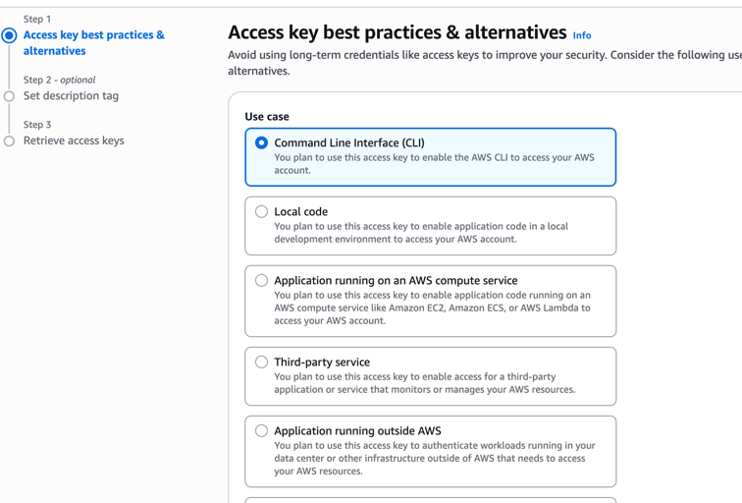

Figure. Access key use case

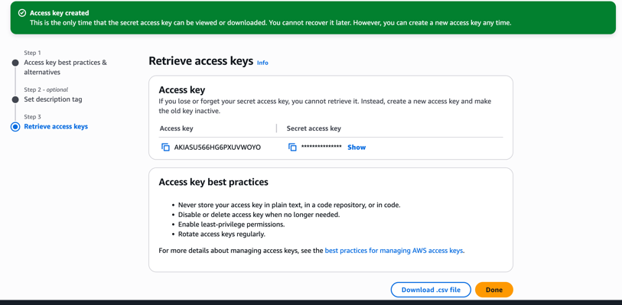

Figure. Access key created successfully

**2.0.3 IAM Role**

For S3 Bucket management, I create a role named CodeDeploy that later will be added to S3 poliy.

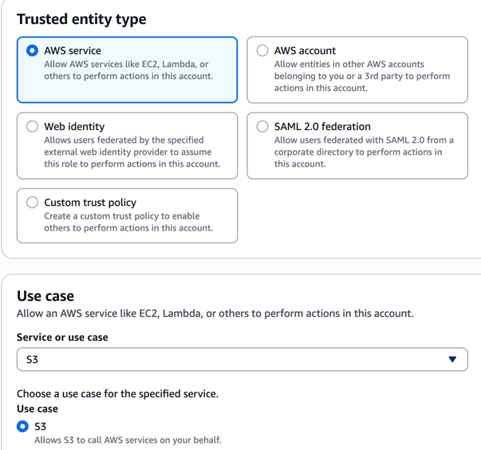

Figure. IAM role creation – Trusted entity and Use case

We add AmazonS3FullAccess policy to this role for S3 management.

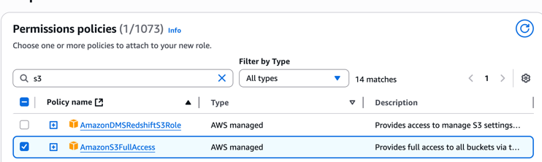

Figure. IAM role permissions policies attaching

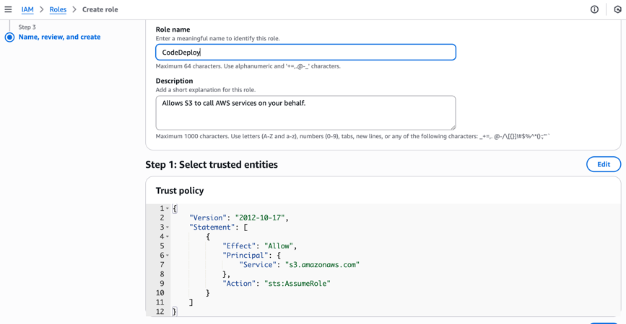

Figure. IAM role permissions policies review

Next, we need to assign the Trust policy for CodeDeploy role properly, originally, the trusted policy at default for this role is:

"Service": "s3.amazonaws.com"

Which will later prevent us to create deployment (and deployment group) with CodeDeploy, therefore, we need to assign *codedeploy.amazonaws.com* service to trusted policy, go to this role CodeDeploy → Trusted relationship and Edit trust policy and edit the JSON cell:

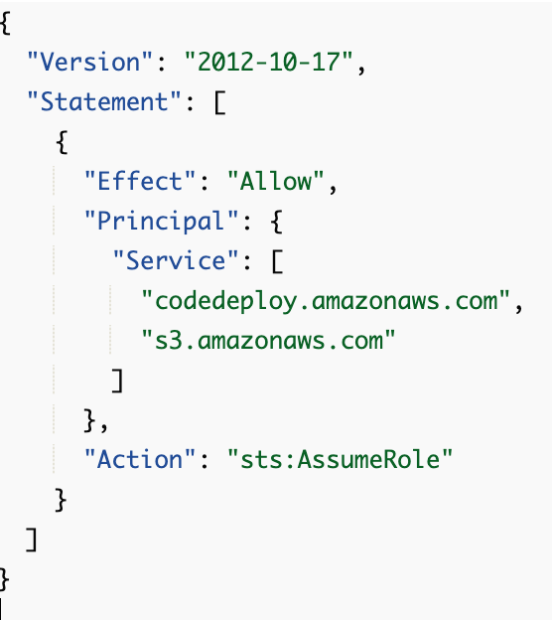

Figure. Add CodeDeploy service to trusted policy.

**2.0.3 IAM User Policies**

Later when we create deployment group to S3, we need *service-role-arn* with proper permission for our IAM user to manage the CodeDeploy role. Go to IAM → Users → KLE → Permissions → Create inline policy

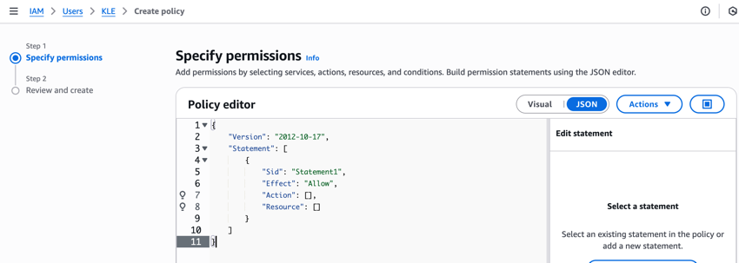

Figure. IAM role permissions inline policy at default

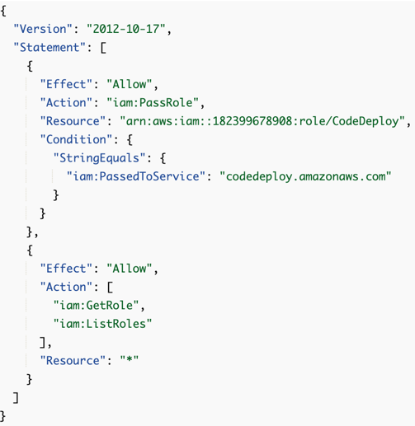

Figure. IAM role permissions inline policy updated

Justifications:

* The iam:PassRole allows IAM user to pass specific role to CodeDeploy.
* The condition ensures we can only pass it to **CodeDeploy**, not any other service.
* The GetRole/ListRoles lets the console/CLI enumerate roles.

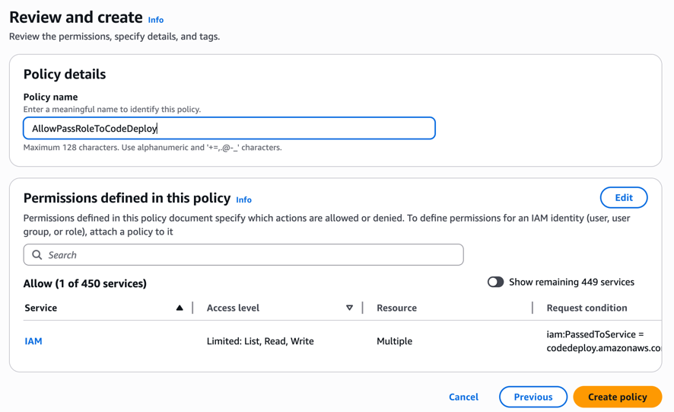

Figure. Inline policy revision and creation

I named this inline policy AllowPassRoleToCodeDeploy.

**2.1 - Pass: EC2→S3 WordPress with CodeDeploy**

Note: Task A, B, C, and D follow walkthroughs as shown in the Appendix.

**A. Create SSH Key Pair**

We first will create a key pairs for later to SSH to EC2 instance.

Navigate to: EC2 → **Key pairs** → Create key pair → Name: *deployment2-key* → Type: **ED25519** → Download .pem (since I use MacOS, which .pem support it). After this, the .pem file will automatically downloaded to local device.

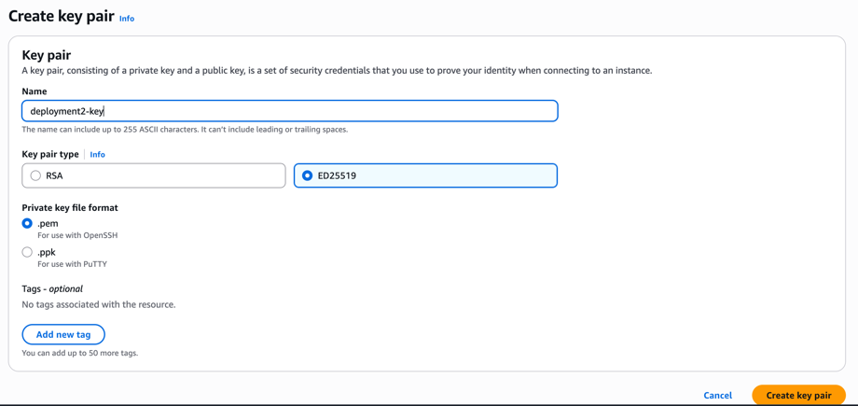

Figure. Create key pairs

**B. Create Security Group (SG)**

Then we need to create security group.

AWS security group to act as a virtual firewall, controlling all network traffic to and from Amazon Elastic Compute Cloud (EC2) instances. By defining specific inbound and outbound rules for ports, protocols, and IP addresses, security groups provide a crucial first layer of defense, allowing only necessary traffic to reach resources and protecting them from unauthorized access and potential threats.

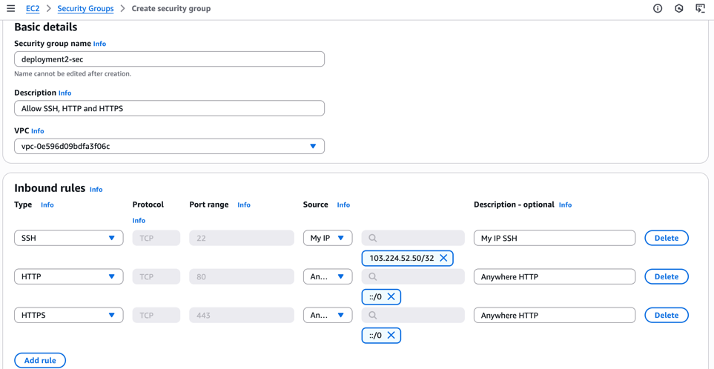

Figure. SG creation details

I named the security group “deployment2-sec” with

Inbound rules: 22 (SSH, **My IP**) - To SSH to EC2 from local device

80 (HTTP, 0.0.0.0/0), - Allow everywhere access to HTTP port 80

443 (HTTPS, 0.0.0.0/0). - Allow everywhere access to HTTPS port 443 (Optional)

However, it’s worth mentioning that everywhere access to your server is not a good practice in real life deployment and should only be used for education and learning activities.

**C. Launch EC2, including Security Group (SG) and Key Pair**

We break this down to 4 steps

1. Navigate to EC2 → **Launch instance** → Name: “wordpress”.
2. **AMI: Amazon Linux 2023**, **Type: t3.micro.** These are default setup.
3. **Key pair:** deployment2-key, **SG:** deployment2-sec. These are our own key and SG.
4. Storage: 8 GB gp3. This is default setup

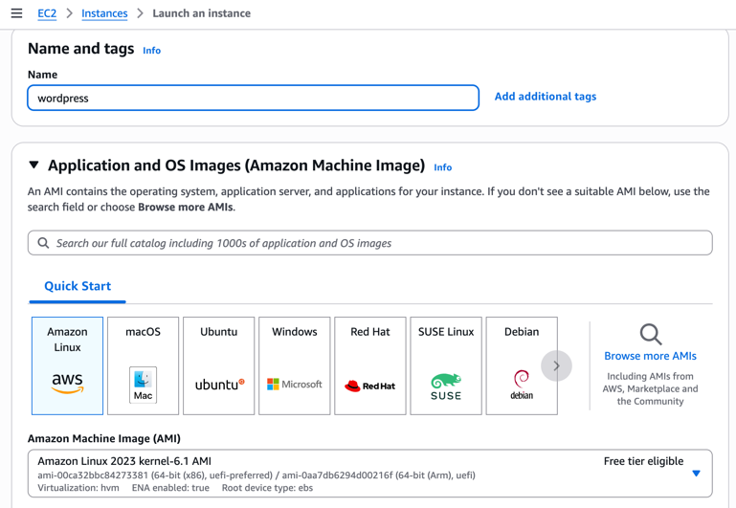

Figure. EC2 Setup - Step 1

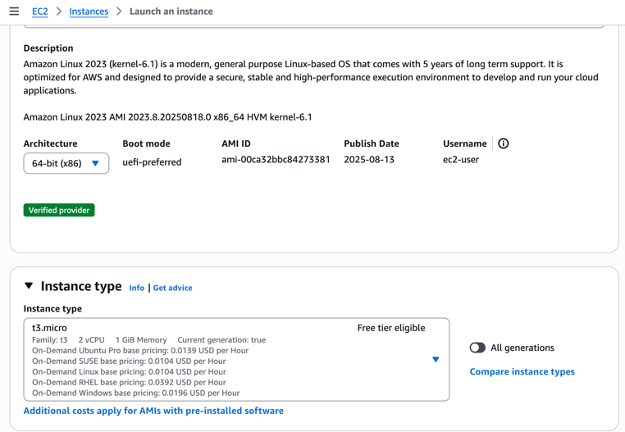

Figure. EC2 Setup - Step 2

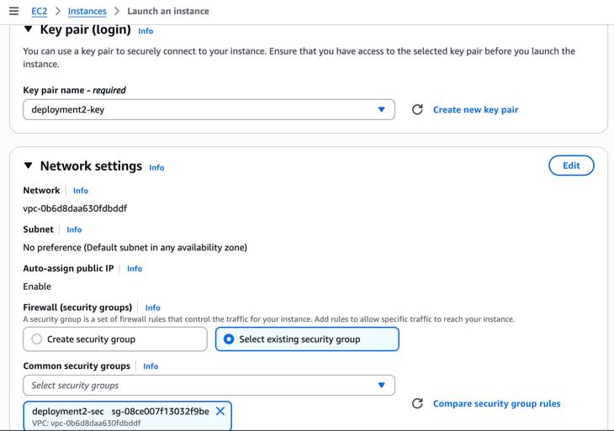

Figure. EC2 Setup - Step 3

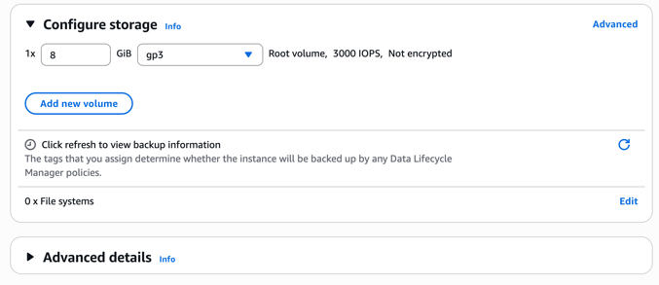

Figure. EC2 Setup - Step 4

Then, we connect the EC2 instance, and remember their Public IP address (13.218.87.205) for SSH login.

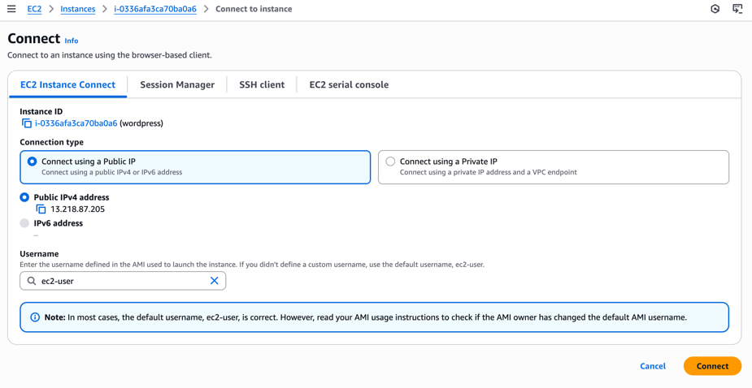

Figure. EC2 Connect

From here, we can directly access to our EC2 instance via CLI.

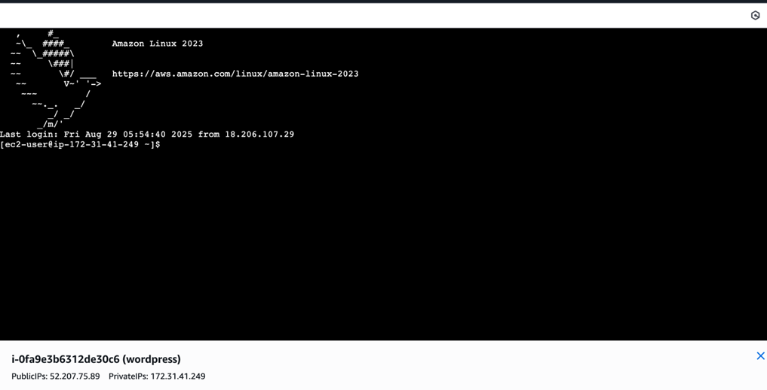

Figure. EC2 instance connect via CLI

**D. SSH to EC2 (from local device)**

We follow the EC2 Connect – SSH client instruction:

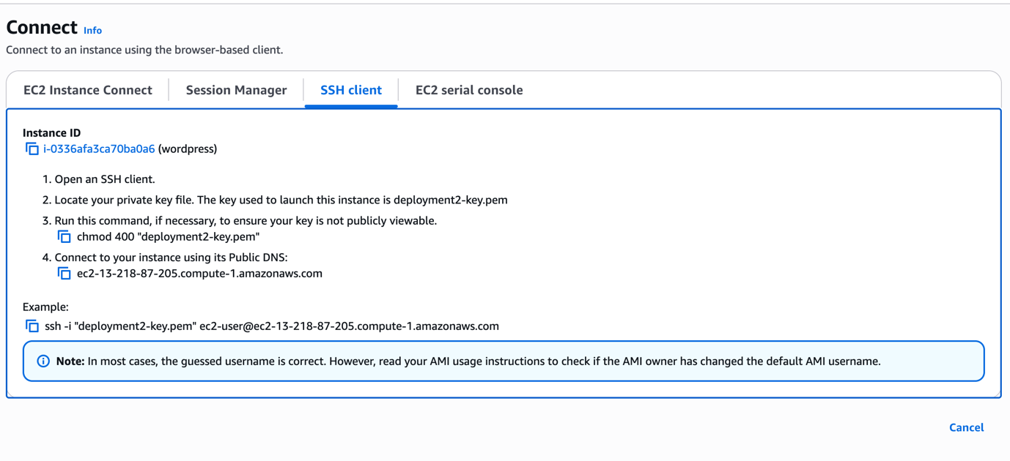

Figure. EC2 instance connect SSH client instruction on Console UI

We will have to SSH to the EC2 instance via Command (Terminal) – AWS CLI:

At first, I ran this command: “ssh -i "deployment2-key.pem" ec2-user@ec2-13-218-87-205.compute-1.amazonaws.com”. Which trigger SSH connection using the downloaded key, to the EC2 instance at destined public IP address we inspected earlier on EC2 Connect.

Note: the screenshot here was captured from previous ssh attempt, with a different EC2 instance.

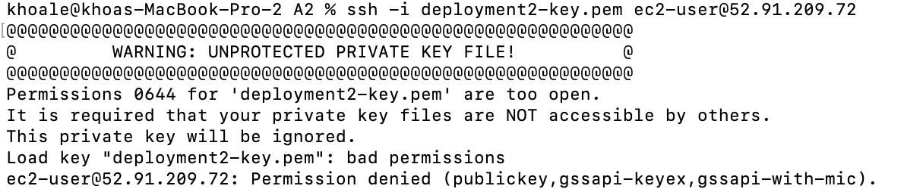

Figure. SSH Warning

However, this was cancelled since we haven’t properly set permission to our key. The private SSH key is analogous to a password; if compromised, an attacker can gain unauthorized access to any system where the corresponding public key is deployed. Strict file permissions ensure that only the key's owner can read or modify it, preventing other users on the same system from accessing or copying it.



Figure. Set key permission

I set the permission with read-only rule to the owner (myself), which I can SSH again.

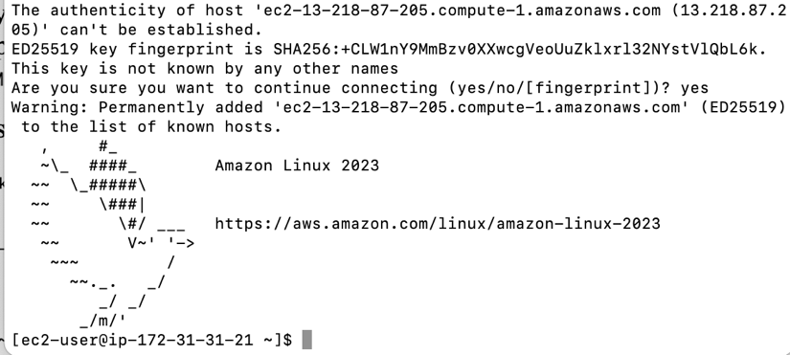

Figure. SSH Connection Successfully

**2.1.3 Installing WordPress on EC2 instance**

**A. Download and unpack WordPress:**

I first Call the wget command to download a copy of the WordPress source code, as a .zip file, to the current directory:

wget <https://github.com/WordPress/WordPress/archive/master.zip>

The call the unzip, mkdir, cp, and rm commands to:

* Unpack the master .zip file into the /tmp/WordPress_Temp directory (folder).

unzip master -d /tmp/WordPress_Temp

* Copy its unzipped contents to the /tmp/WordPress destination folder.

mkdir -p /tmp/WordPress

cp -paf /tmp/WordPress_Temp/WordPress-master/* /tmp/WordPress

* Delete the temporary /tmp/WordPress_Temp folder and master file.

rm -rf /tmp/WordPress_Temp

rm -f master

Inspect /tmp folder again:

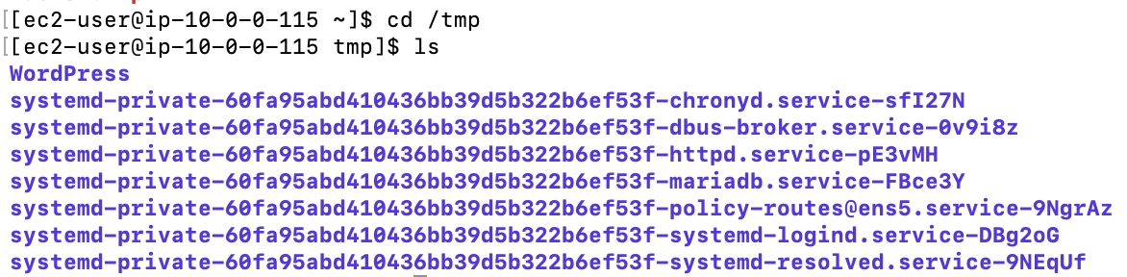

Figure. /tmp folder setup

**B. Create deployment scripts**

First I need to initiate the directory:

mkdir -p /tmp/WordPress/scripts

I can create these bash files using Nano tools:

**install_dependencies.sh** – installs PHP, Apache, MariaDB (or MySQL) and enables PHP support (previously done).

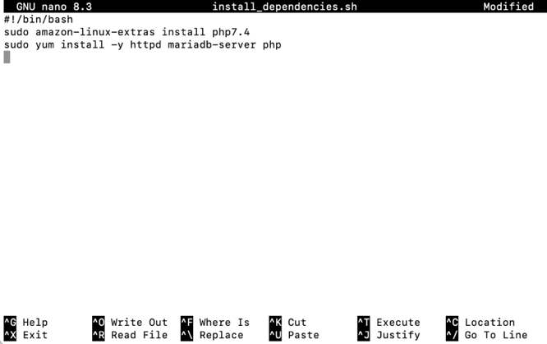

Figure. install_dependencies.sh

**start_server.sh** – starts HTTPD, MariaDB and PHP-FPM:

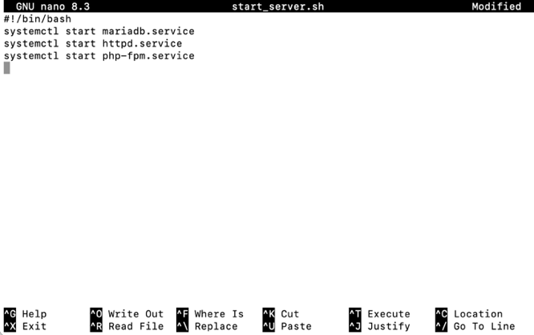

Figure. start_server.sh

**stop_server.sh** – stops them if running:

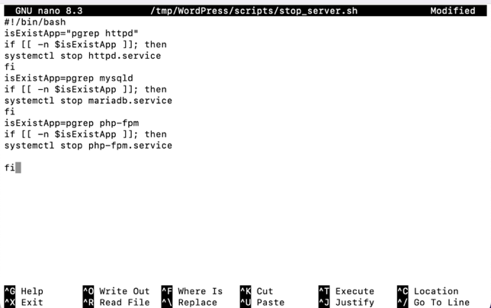

Figure. stop_server.sh

**create_wp_db.sh** – creates a database for our wordpress table:

1. CREATE DATABASE IF NOT EXISTS wordpress;

* This creates a new database named wordpress if not exist.
* It will hold all the tables WordPress needs (users, posts, settings, etc.).
* If we don’t run this, WordPress has nowhere to store its data

2. CREATE USER 'wpuser'@'localhost' IDENTIFIED BY 18122003!';

* This creates a new **database user account** called **wpuser**.
* The @'localhost' part means this user can only connect **from the same server (the EC2 instance itself)** — not from external machines.
* 18122003!' is my custom password for this user.

3. GRANT ALL PRIVILEGES ON wordpress.* TO 'wpuser'@'localhost';

* This gives the new user full privileges on all tables inside the **wordpress** database (wordpress.*).
* Privileges include SELECT (read), INSERT, UPDATE, DELETE, CREATE TABLE, etc.
* It does **not** give access to any other databases (e.g., mysql or sys).

4. FLUSH PRIVILEGES;

* This tells MariaDB/MySQL to reload the privilege table so changes take effect immediately.

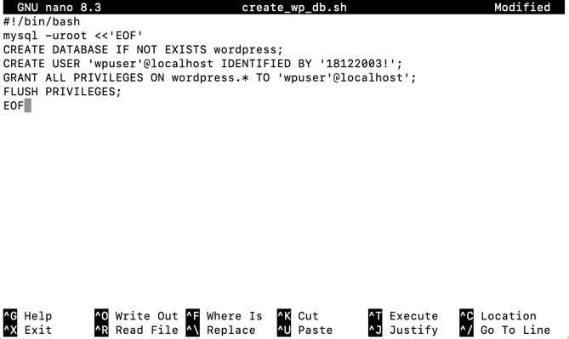

Figure. create_wp_db.sh

**change_permissions.sh** – temporarily relaxes permissions so WordPress can write to its own directory during configuration:

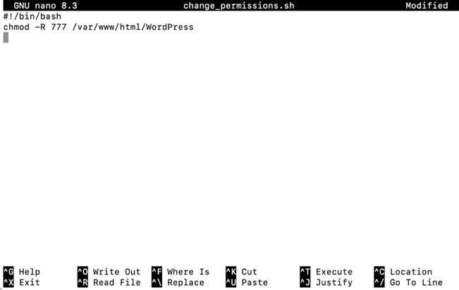

Figure. change_permissions.sh

After deploying and setting up WordPress, the system reset permissions with:

chmod -R 755 /var/www/html/WordPress

Make all deployment scripts executable:

chmod +x /tmp/WordPress/scripts/*

**Justifications:**

chmod -R 755 /var/www/html/WordPress:

* Sets **directories** to 755:
  + Owner (apache) = read/write/execute.
  + Group/others = read/execute only.
* The execute bit on directories means “can enter/list the directory.” Without it, Apache can’t traverse into directories to serve files.

These are good practices for security.

**C. Add an AppSpec file:**

We add an appspec.yml file to WordPress source (/tmp/WordPress) and tells the system (CodeDeploy) where to copy files and which scripts to run:

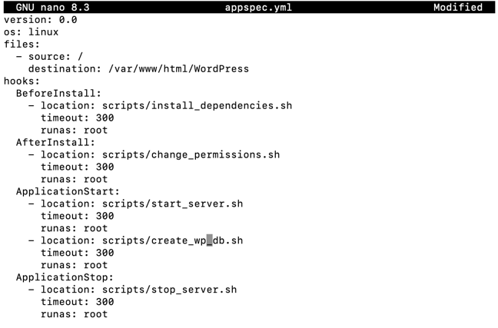

Figure. appspec.yml

CodeDeploy uses this file during deployment to orchestrate copying WordPress into the Apache root and calling the scripts in the right order.

**2.1.4 Provision an Amazon S3 bucket**

This task follow the walkthroughs in Appendix, with our bucket name/id *amzn-s3-wp-bucket* already occupied so we sightly rename it to *amzn-s3-wp1-bucket*.

**A. Create a S3 Bucket**

We run this command to create a S3 bucket named “amzn-s3-wp1-bucket” from CLI:

aws s3 mb s3://amzn-s3-wp1-bucket --region region

Or go to Console UI at <https://us-east-1.console.aws.amazon.com/s3/>

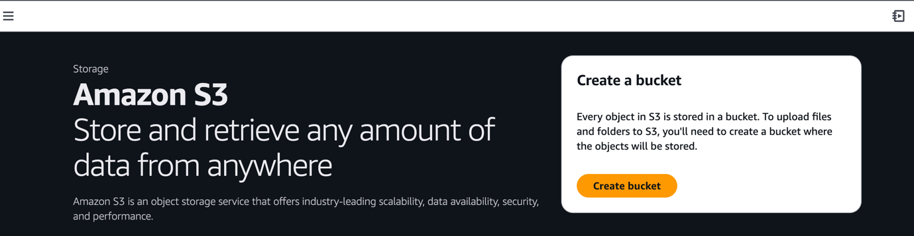

Figure. Amazon S3 Dashboard

Proceed with Create bucket button, I created a bucket name “amzn-s3-wp1-bucket”, all settings at default – Location: US East (N. Virginia) us-east-1.

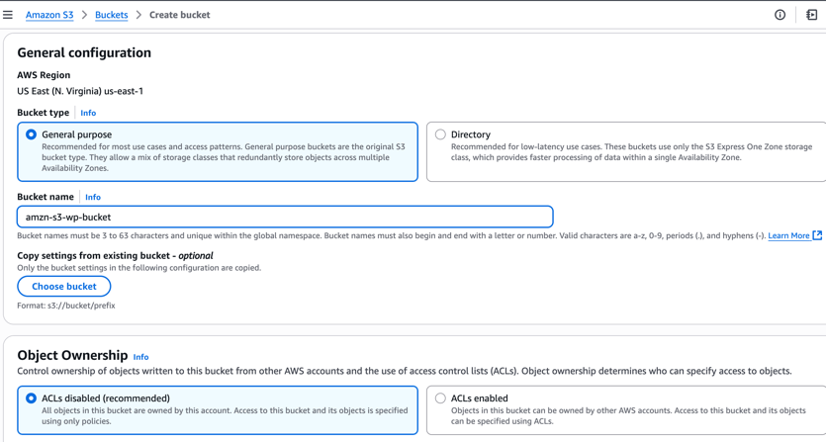

Figure. Bucket name

**B. Grant the right permissions (bucket policy)**

* Go to the **S3 Console** → open this bucket (amzn-s3-wp1-bucket).
* Click the **Permissions** tab.
* Scroll down to **Bucket policy** → **Edit**.
* Paste the JSON policy (upload permissions, instance role download permissions, optional hardening).
* Save changes.

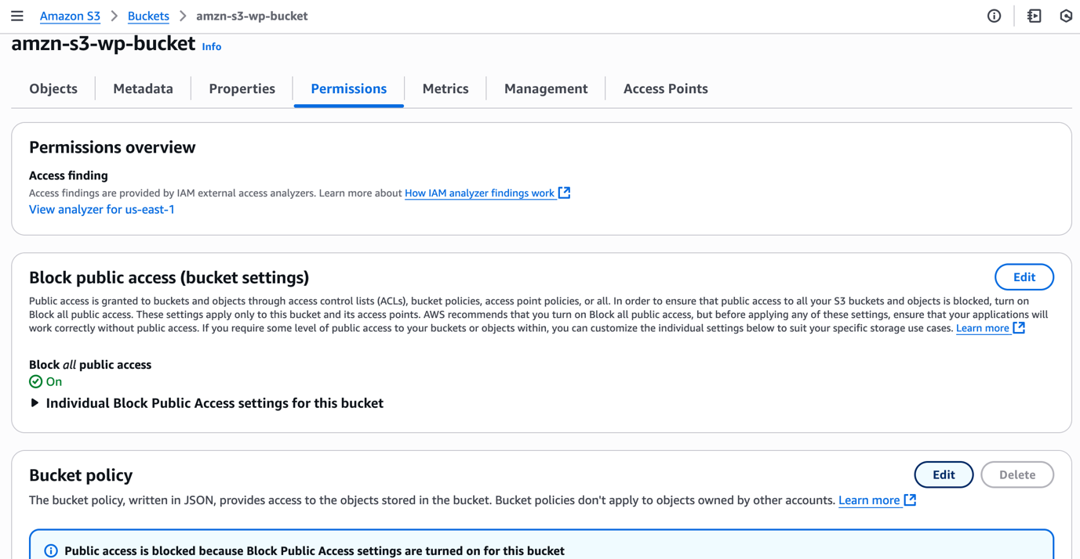

Figure. Edit bucket policy

The S3 bucket policy contains **multiple statements**, each addressing a different actor and action, this is linked to our IAM user with roles as previously configured:

1. **Uploader permissions (PutObject) - AllowUploaderToPut**

* Grants my AWS account using the root IAM user with already configured permissions to upload application revisions.
* Without this, the aws deploy push command or manual uploads would be blocked.
* Restricting the Resource to bucket/* ensures only **objects inside the bucket** can be written, not the bucket itself.

1. **CodeDeploy EC2 read permissions (GetObject) – AllowCodeDeployRoleToRead**

* Grants the **EC2 instance profile role** used by CodeDeploy the ability to fetch files (the WordPress ZIP bundle).
* Necessary during the deployment lifecycle, when the agent on the instance pulls the revision package from S3.
* Again scoped only to the object keys in this bucket.

1. **CodeDeploy EC2 role list permissions (ListBucket) – AllowCodeDeployRoleToList**

* Allows the same instance role to list object keys inside the bucket.
* This is essential because the CodeDeploy agent often needs to confirm the exact object key and revision version before fetching.
* Note that ListBucket is applied to the **bucket ARN only**, whereas GetObject applies to bucket/*.

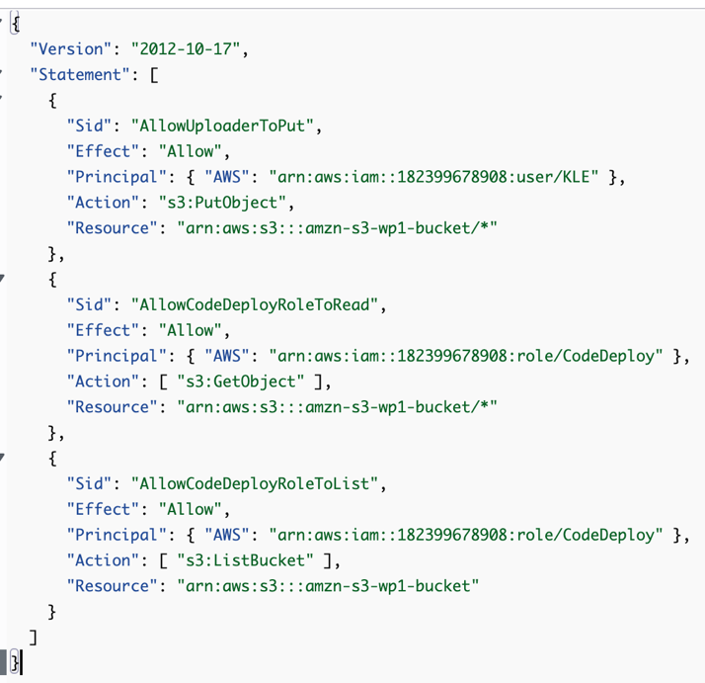

Figure. Bucket policy content

**C. Prepare and bundle the application folder and push to Amazon S3**

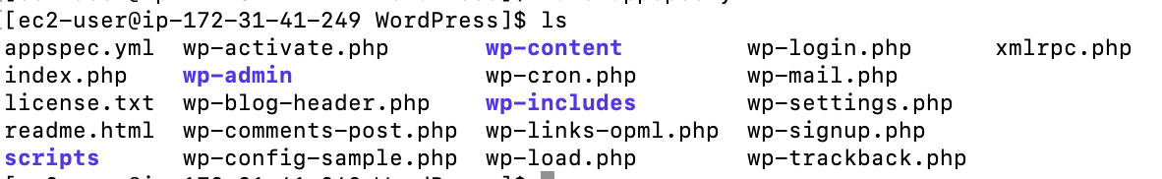



Figures. WordPress folder setup

We use ‘ls’ command to inspect our WordPress folder and it aligned with our tutorial

**D. Register the CodeDeploy application**

First, we need to inspect the bucket Properties and get its ARN, which is *arn:aws:s3:::amzn-s3-wp1-bucket.*

We first need to configure the AWS credential (from my personal AWS account) to CLI, in order to register and create AWS deploy application. First, I need to run:

aws configure

Then, fill in details from my IAM user – Acess key:

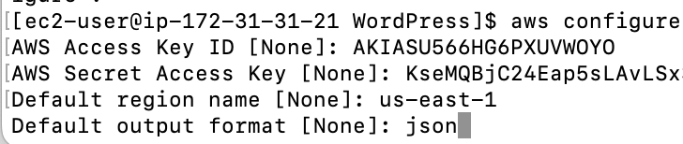

Figures. Prompt in my AWS Secret key values and preferences

Then, fill I proceed with application creation:



Now we can push the app (zip file) to S3 with this command:

aws deploy push \

--application-name WordPress_App \

--s3-location s3://amzn-s3-wp1-bucket/WordPressApp.zip \

--ignore-hidden-files

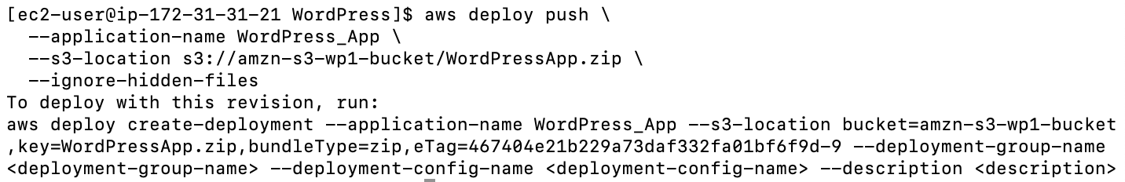

Figures. WordPress_App deployed successfully to S3

**2.1.5 Deploy application revision with CodeDeploy**

**A. Create Deployment Group**

Before creating the deployment group, we need to create EC2 tag, such:

* Key: Name
* Value: CodeDeployApp
* Resources is our EC2 instance’s id.

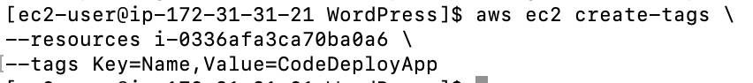

Figures. Create EC2 tags

Then creating the deployment group with CLI, with a deployment group named WordPress_DepGroup:

This can be done on CLI following this command:

aws deploy create-deployment-group \

--application-name WordPress_App \

--deployment-group-name WordPress_DepGroup \

--deployment-config-name CodeDeployDefault.OneAtATime \

--ec2-tag-filters Key=Name,Value=CodeDeployApp,Type=KEY_AND_VALUE \

--service-role-arn arn:aws:iam::182399678908:role/CodeDeploy

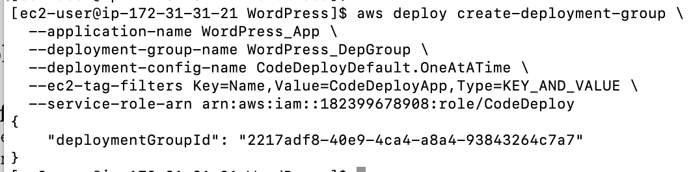

Figures. Create deployment group sucessfully

**B. Deploy App Revision**

Before we create a deployment, the instances in the deployment group must have the CodeDeploy agent installed. We can install the agent from the command line with AWS Systems Manager by the following command:

aws ssm create-association \

--name AWS-ConfigureAWSPackage \

--targets Key=tag:Name,Values=CodeDeployApp \

--parameters action=Install,name=AWSCodeDeployAgent \

--schedule-expression "cron(0 2 ? * SUN *)"

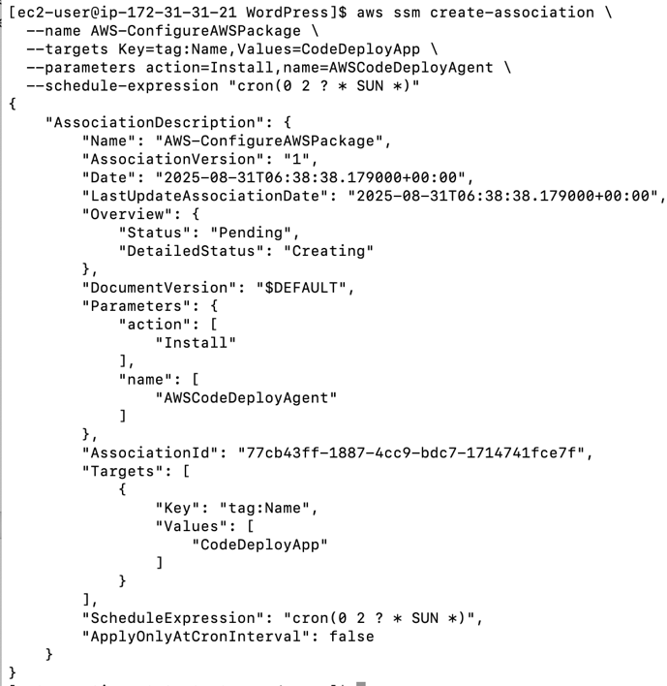

Figures. Create CodeDeploy agent association

We tried to SSH and inspect our CodeDeploy agent:



Figures. CodeDeploy agent failed

Which failed. We manually install the CodeDeploy agent on AL2023 (since EC2 is Amazon Linux 2023), and the AWS-ConfigureAWSPackage document is written for Amazon Linux 2 and older). This CLI command does all of these at once:

* Install the prerequisites
* Download and install the CodeDeploy agent
* Enable and start the agent

sudo dnf -y install ruby wget

cd /tmp

wget https://aws-codedeploy-us-east-1.s3.us-east-1.amazonaws.com/latest/codedeploy-agent.noarch.rpm

sudo dnf install -y ./codedeploy-agent.noarch.rpm

sudo systemctl enable --now codedeploy-agent

sudo systemctl status codedeploy-agent --no-pager

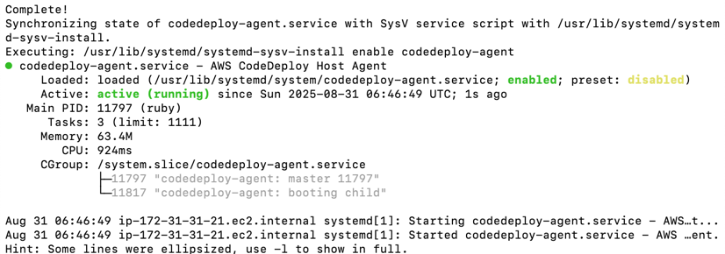

Figures. Successful CodeDeploy agent initiation

To register app revision:

aws deploy register-application-revision \

--application-name WordPress_App \

--s3-location bucket=amzn-s3-wp1-bucket,key=WordPressApp.zip,bundleType=zip

Now deploy the app revision with CLI, with the deployment group.

aws deploy create-deployment \

--application-name WordPress_App \

--deployment-group-name WordPress_DepGroup \

--deployment-config-name CodeDeployDefault.OneAtATime \

--s3-location bucket=arn:aws:s3:::amzn-s3-wp1-bucket,key=WordPressApp.zip,bundleType=zip

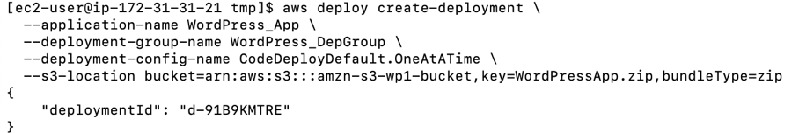

Figures. Deploy the app revision

Later, we can list all deployment for inspection with:

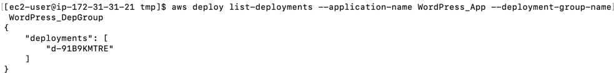

Figures. List deployment

And inspect any deployment’s status using the ID with CLI command:

aws deploy get-deployment --deployment-id <ID> --query 'deploymentInfo.status'

Our deployment failed:



Figures. Failed deployment

I can use this command to review logs from CodeDeploy agent:

sudo tail -n 50 /var/log/aws/codedeploy-agent/codedeploy-agent.log

Error now shown as:

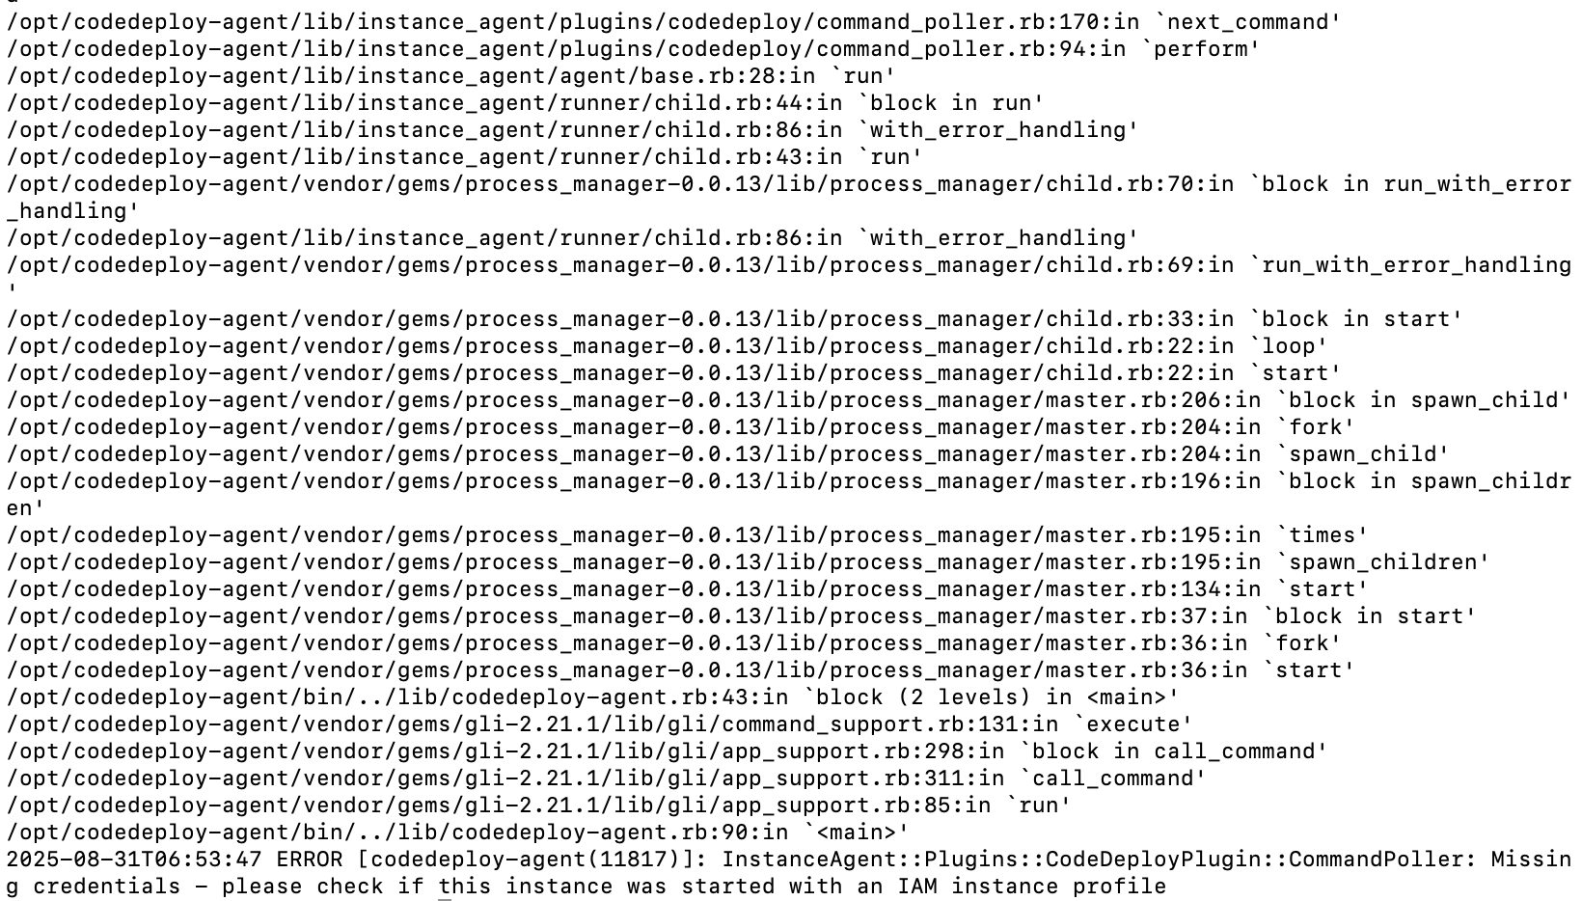

Figures. Deployment error logs

Which means

* The CodeDeploy agent is installed and running fine.
* But it **cannot get AWS credentials** because this EC2 instance has **no IAM instance profile** (role) attached, or the role doesn’t have the right permissions.
* CodeDeploy agents *only* use **instance profile credentials** (via EC2 metadata service). They will ignore any ~/.aws/credentials configured with aws configure that earlier we have set.

So then I added another inline policy (named CRUDTags), which allow the CodeDeploy role to have better access in describing/previewing EC2 instance, as well as get resources, key and value from the tag.

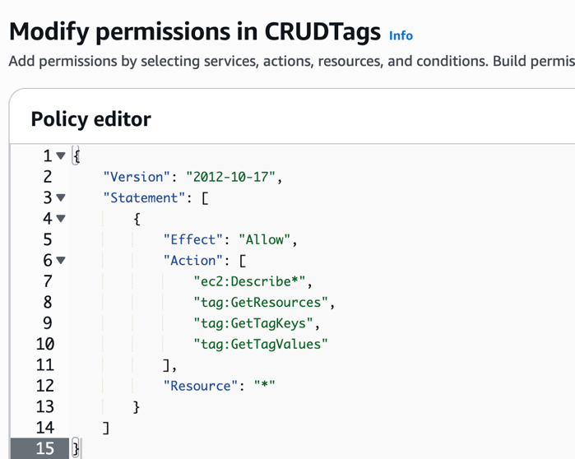

Figures. CRUDTags inline permission

We are now able to create deployment from local device:

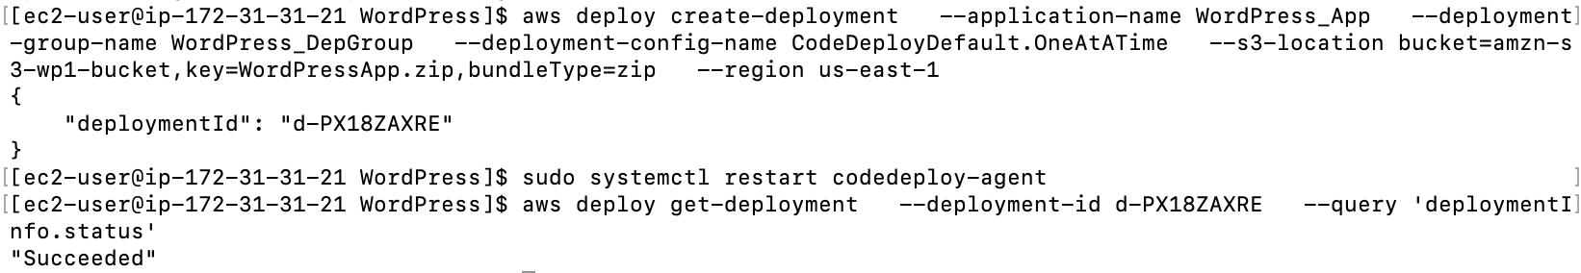

Figures. Sucessful Deployment

At default, Apache will only support index.html, therefore, we edit */etc/httpd/conf/httpd.conf* file ensuring it support index.php too.

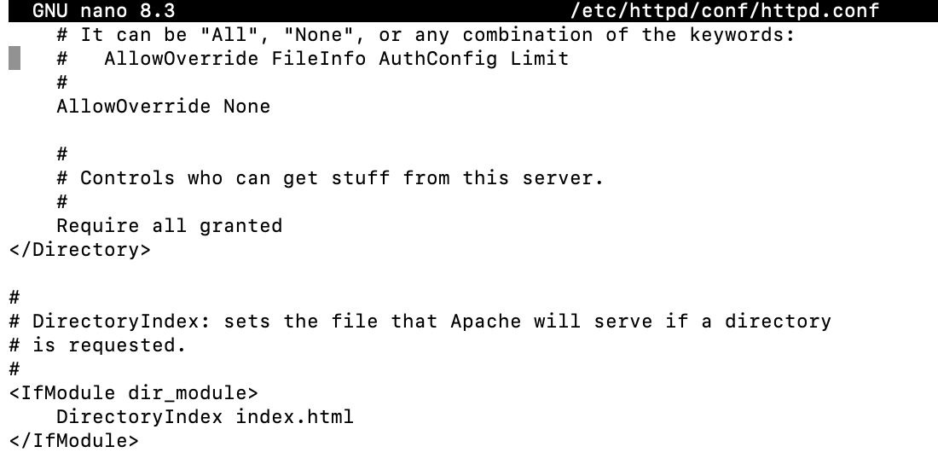

Here we added index.php alongside in DirectoryIndex.

Figure. Apache httpd only support index.html at default

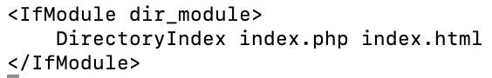

Figure. Added index.php

I also attached and elastic IP to this instance at *34.202.24.217*.

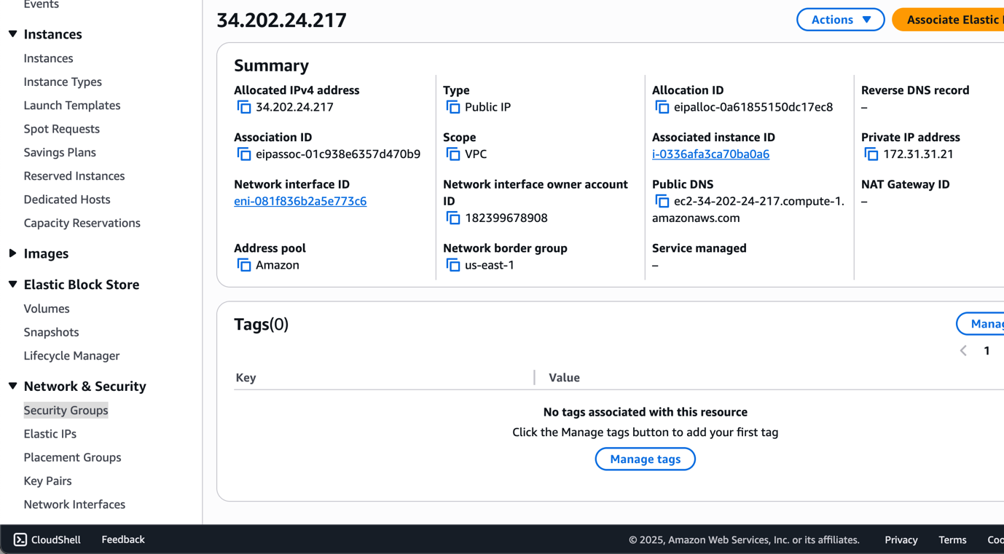

Figures. Elastic IP to EC2

Now access WordPress from our public DNS (*34.202.24.217*), our WordPress webapp is shown properly.

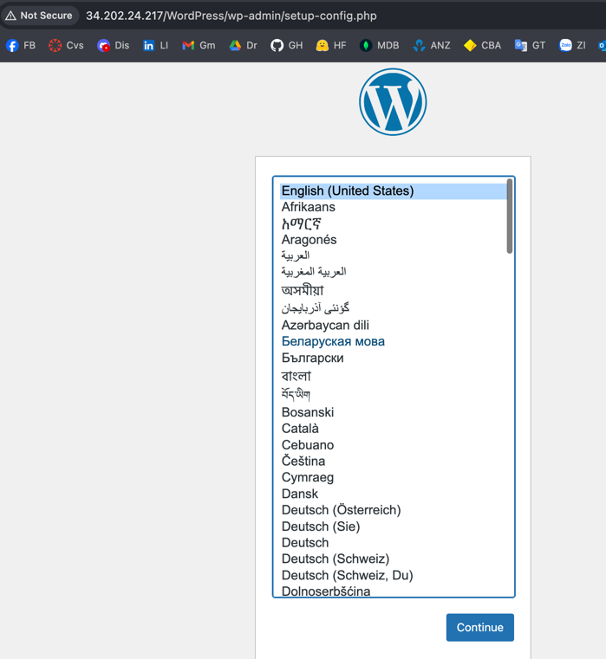

Figure. WordPress app setup page on browser

Then we will prompted for the database connection page:

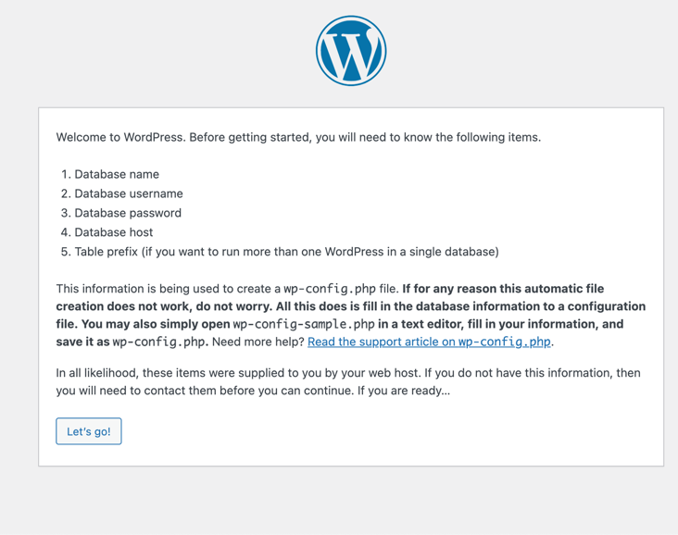

Figure. WordPress app Database connection page

We fill in database details as earlier configured in *create_wp_db.sh.*

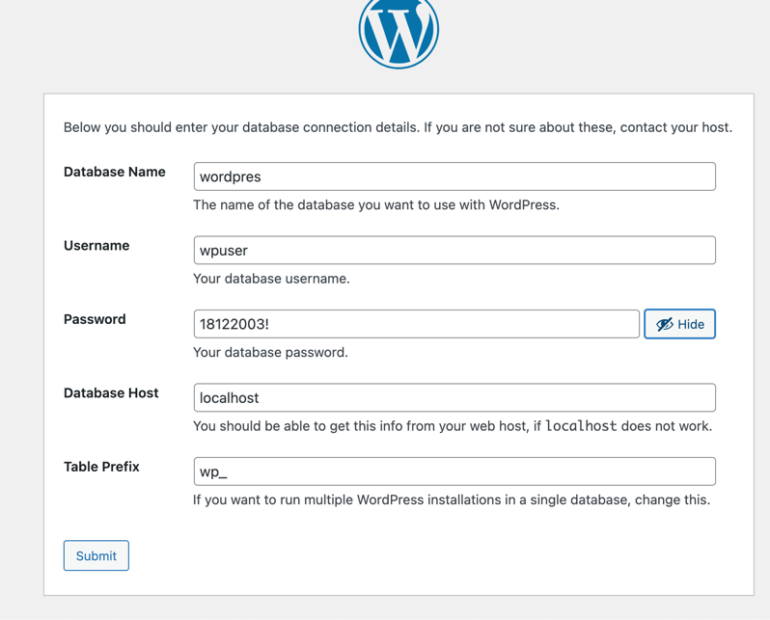

Figure. WordPress database configs

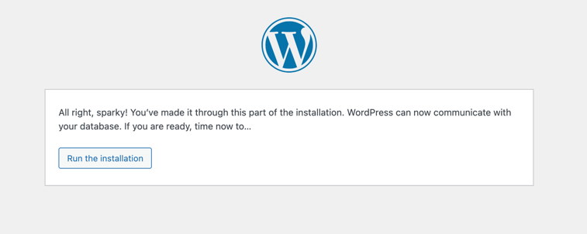

Figure. WordPress database installation completed

Now, the WordPress app now prompt us to fill in information for the final step before installation (I used the default password o2k6!tb!vnUDo^A*$z):

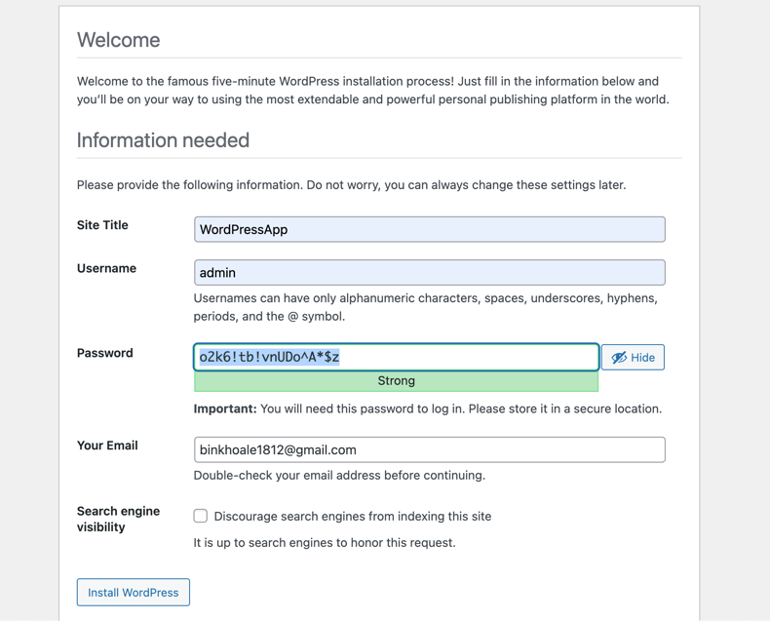

Figure. WordPress information page

Once installed, we can login.

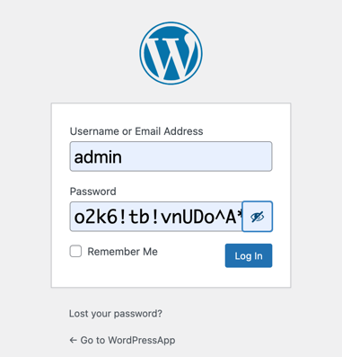

Figure. WordPress login page

Now the app is finalised.

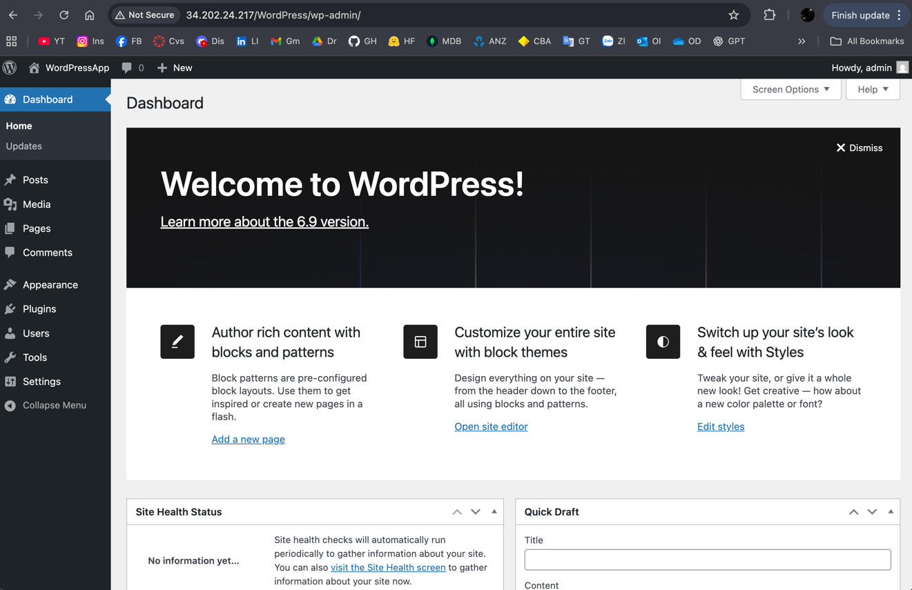

Figure. WordPress app working

**Task 2.2 - Credit: ELB, External RDS database**

**2.2.1 Create an Elastic Load Balancer (ALB)**

1. **EC2 → Load Balancers → Create load balancer → Application Load Balancer**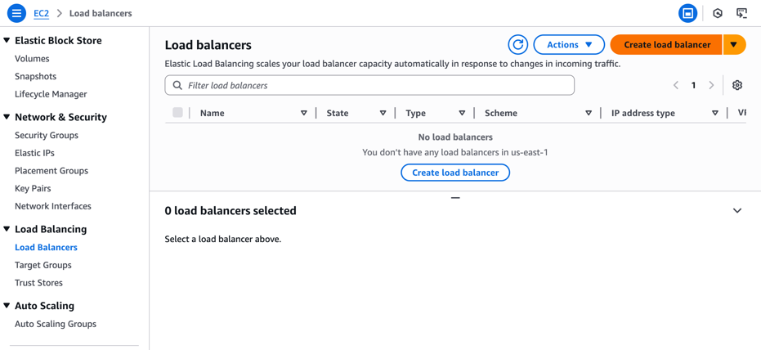

Figure. Create Load Balancer on Console UI

We then proceed with Application Load Balance, as its description matches our app requirements:

“Choose an Application Load Balancer when you need a flexible feature set for your applications with HTTP and HTTPS traffic. Operating at the request level, Application Load Balancers provide advanced routing and visibility features targeted at application architectures, including microservices and containers.”

Now fill in ALB details:

* Name: *wp-alb*
* Scheme: **Internet-facing**, IPv4
* VPC: default
* Subnets: pick **2 public subnets** (e.g., us-east-1a, us-east-1b)
* Security group: choose *deployment2-sec* earlier configured
* Listeners: HTTP :80 (optional HTTPS :443 later if we have ACM)

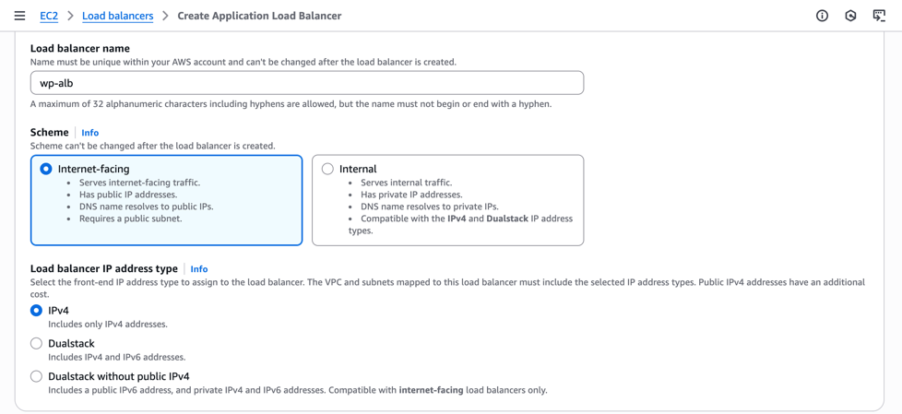

Figure. ALB name – scheme – IP address type

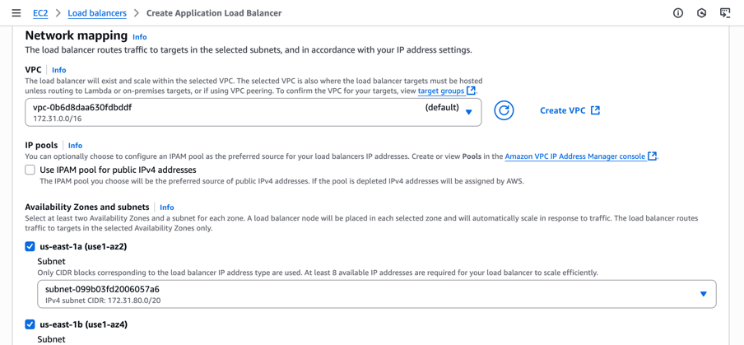

Figure. ALB network mapping

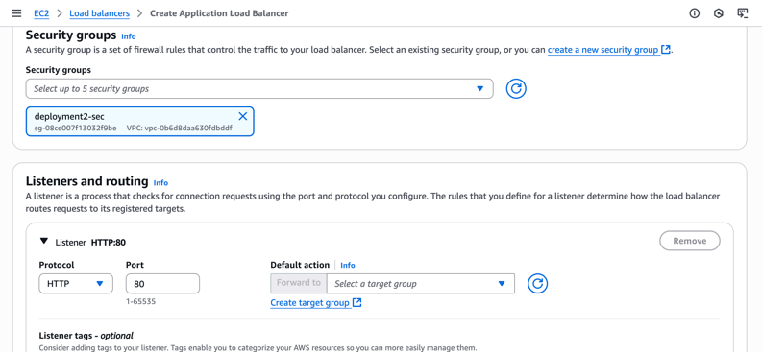

Figures. ALB SG – Listener

Note that we haven’t got the Target Group, which will be created in the next step:

1. **Target Group** → Create target group

* Target type: **Instances**
* Name: *wp-tg-http*
* Protocol/Port: HTTP:80,; VPC: default
* **Health check path:** since this app is under a subfolder, set */WordPress/* or */WordPress/index.php* for absolute redirection
* Register current EC2 instance.

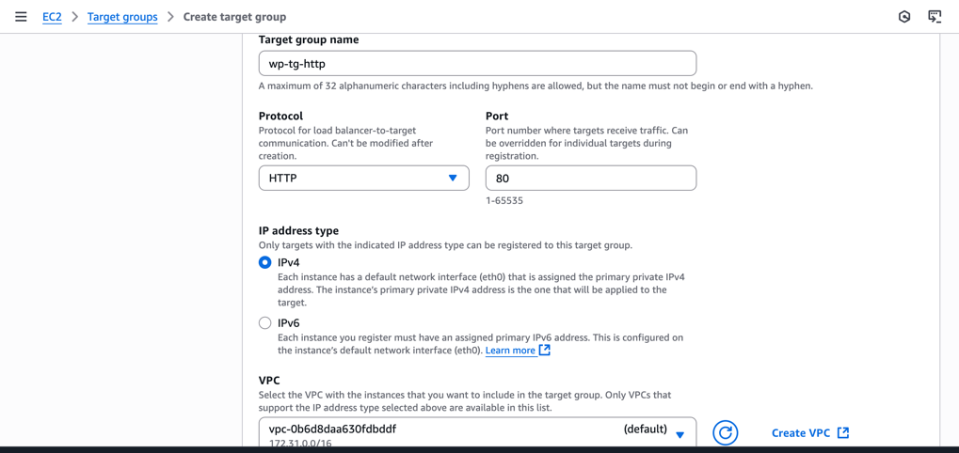

Figure. Target group details

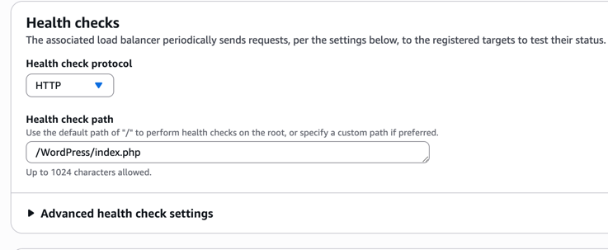

Figure. Target group health check

1. Back on the ALB, **attach the target group** to listener :80

* Head back to ALB configuration and add the target group we just created *wp-tg-http*.

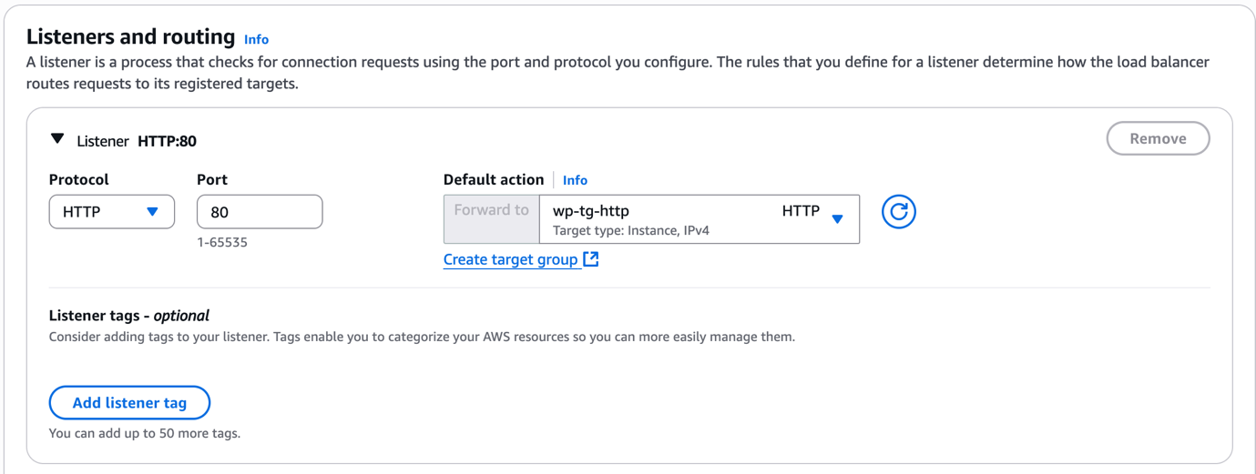

Figure. Attach target group to ALB

* (Optional) If using HTTPS: request an ACM cert and add a :443 listener with default action = forward to *wp-tg-http*

**2.2.2 Re-install / Migrate WordPress to External RDS**

1. **Aurora and RDS → Create a database**
   * Engine: **MySQL** (MariaDB also fit for this project)
   * **Template:** Free-tier, **Availability and durability:** Single-AZ (for low-cost)
   * DB instance id: *wp-rds*
   * Master username: *admin*, Credentials management: Self managed (free)
   * Connectivity: **Public access = No** (preferred).
   * **VPC security group:** Create *rds-sg* with inbound **3306 the EC2 SG** only.
   * **Other configurations would be kept as default.**

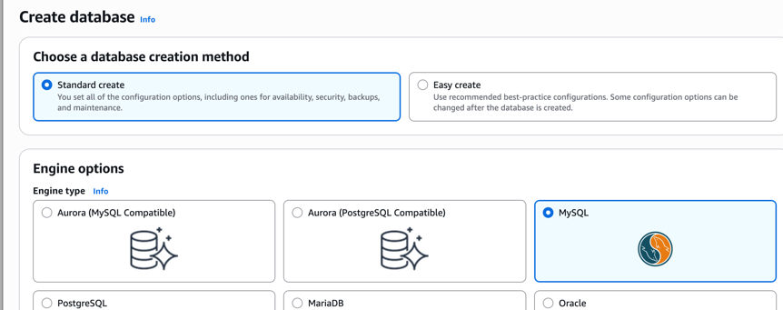

Figure. Create MySQL DB

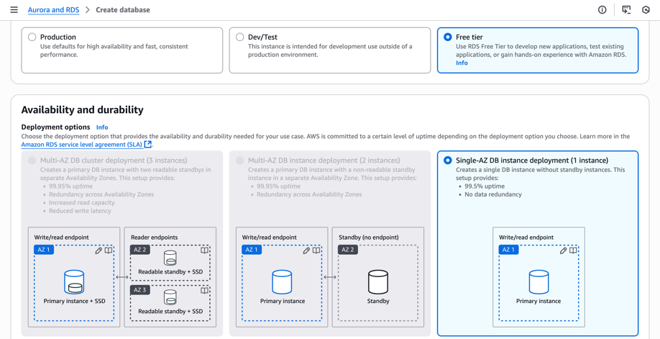

Figure: RDS Templates and Availability and durability

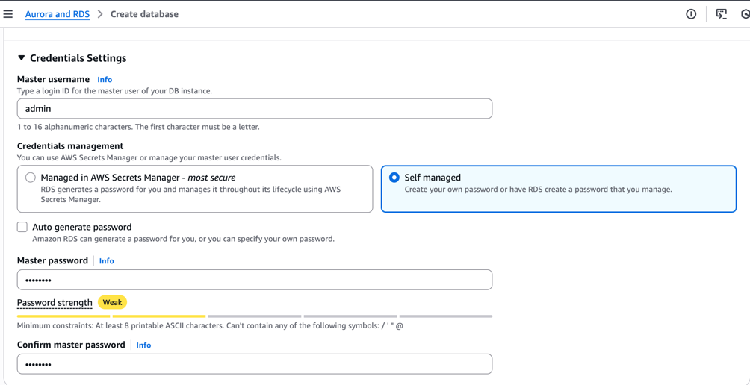

Figure: RDS credentials

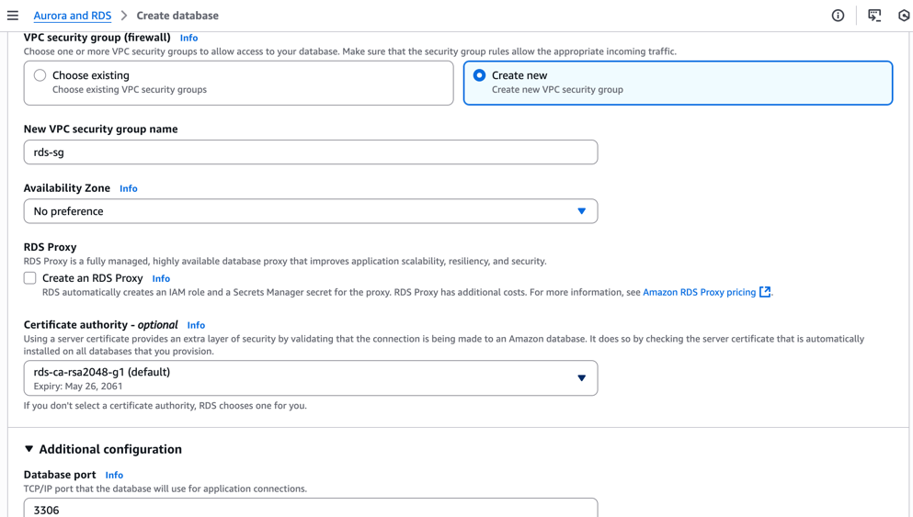

Figure: RDS VPC Security Group

1. After RDS is Available, note the **Endpoint** (wp-rds.ck1mocq60lmu.us-east-1.rds.amazonaws.com).

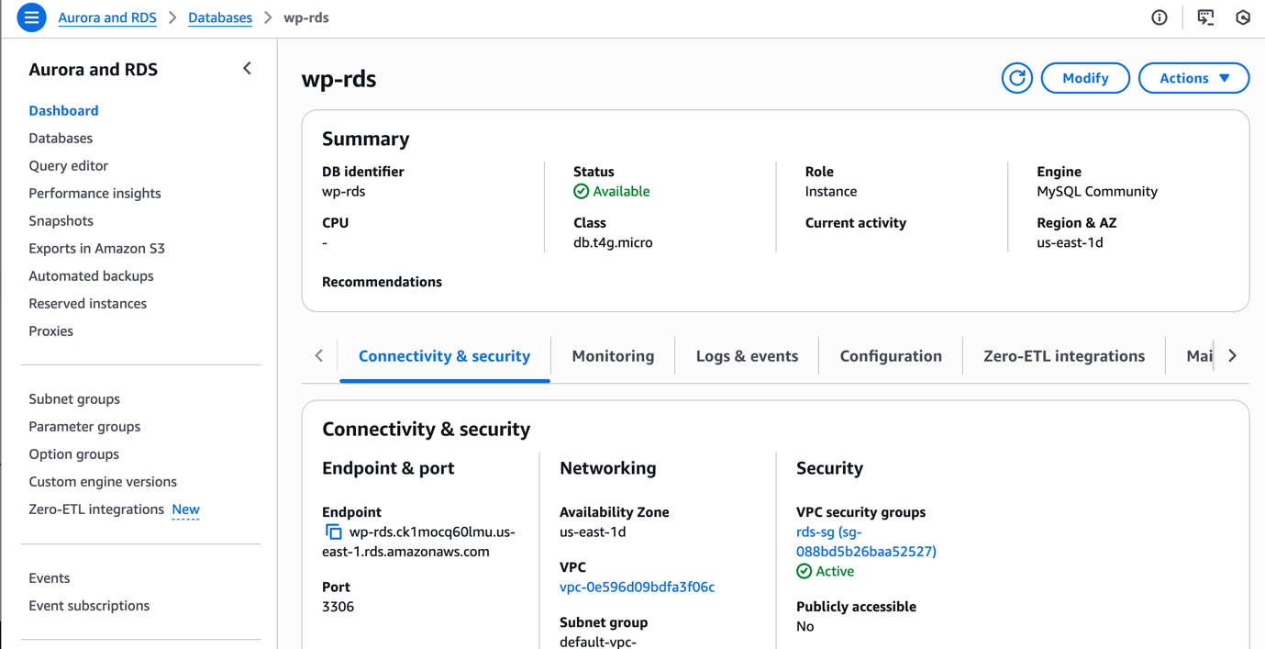

Figure: RDS Creation

**2.2.2 Re-install / Migrate WordPress to external RDS**

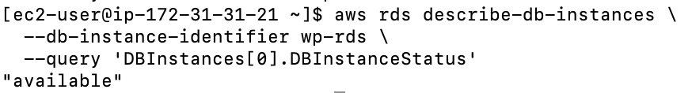

Figure: RDS DB status

**1. Dump local DB**

mysqldump -u wpuser -p'18122003!' wordpress > /tmp/wp.sql

**2. Create DB & user on RDS and grant**

RDS_ENDPOINT="wp-rds.ck1mocq60lmu.us-east-1.rds.amazonaws.com"

mysql -h "$RDS_ENDPOINT" -u admin -p <<'SQL'

CREATE DATABASE IF NOT EXISTS wordpress;

CREATE USER IF NOT EXISTS 'wpuser'@'%' IDENTIFIED BY '18122003!';

GRANT ALL PRIVILEGES ON wordpress.* TO 'wpuser'@'%';

FLUSH PRIVILEGES;

SQL

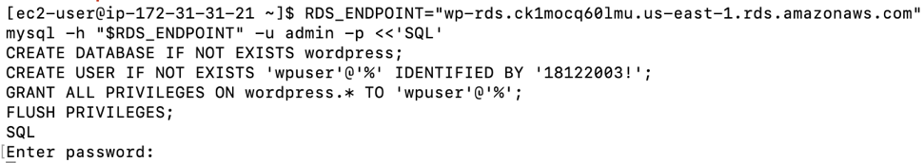

Figure: RDS MySQL DB and user creation didn’t response

I double checked RDS SG rules, and found out we set inbound 3306 from my IP by mistake and wasn’t from EC2 instance:

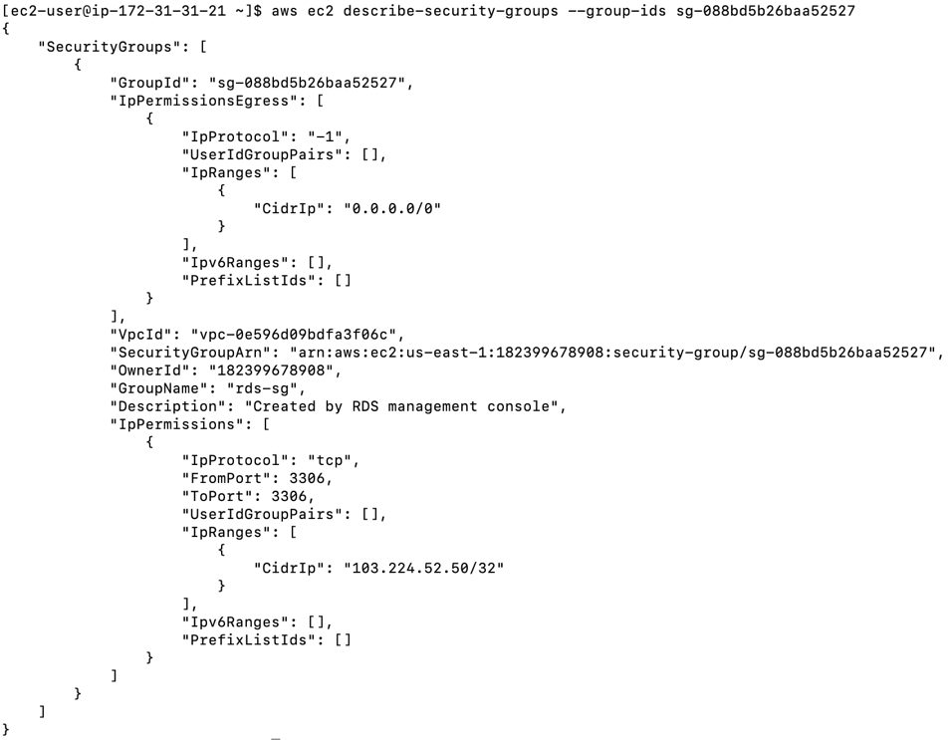

Figure: RDS SG wrong configurations

So I need to allow EC2 → RDS traffic via SG (RDS SG has 3306 inbound rule from deployment2-sec SG). This command was executed:

RDS_SG=sg-088bd5b26baa52527

EC2_SG=sg-0c42d64ebfc2fd8bd

aws ec2 authorize-security-group-ingress \

--group-id $RDS_SG \

--protocol tcp --port 3306 \

--source-group $EC2_SG

Then I rerun the command to recreate DB & user on RDS and grant permission. It then worked.

**3. Import to RDS**

mysql -h "$RDS_ENDPOINT" -u wpuser -p'18122003!' wordpress < /tmp/wp.sql

**4. Point WordPress to RDS**

RDS_ENDPOINT="wp-rds.ck1mocq60lmu.us-east-1.rds.amazonaws.com"

I will need to redefine the database’s host, username and password on WordPress’s configuration file.

sudo sed -i "s/^define('DB_HOST'.*/define('DB_HOST', '$RDS_ENDPOINT');/" /var/www/html/WordPress/wp-config.php

sudo sed -i "s/^define('DB_USER'.*/define('DB_USER', 'wpuser');/" /var/www/html/WordPress/wp-config.php

sudo sed -i "s/^define('DB_PASSWORD'.*/define('DB_PASSWORD', '18122003\!');/" /var/www/html/WordPress/wp-config.php

Then restart Apache:

sudo systemctl restart httpd

**2.2.3 Backup instance to S3 (files + DB)**

We’ll use S3 bucket *amzn-s3-wp1-bucket.*

* S3 → **amzn-s3-wp1-bucket** → Create folder *backups/*
* (Optional) **Versioning ON**, lifecycle rules (IA after 30 days, Glacier after 90).

**CLI commands:**

**1. Define variables**

* BUCKET = S3 bucket name where backups will be stored.
* STAMP = a timestamp string in the format YYYYMMDD-HHMM.

BUCKET=amzn-s3-wp1-bucket

STAMP=$(date +%Y%m%d-%H%M)

**2. Back up WordPress application files**

sudo tar czf /tmp/wp-files-$STAMP.tgz -C /var/www/html WordPress

* tar = creates an archive of files.
* Options:
* c = create
* z = compress with gzip
* f = filename for the archive

aws s3 cp /tmp/wp-files-$STAMP.tgz s3://$BUCKET/backups/$STAMP/wp-files.tgz

* aws s3 cp = copy file to S3.
* Destination = s3://amzn-s3-wp1-bucket/backups/<timestamp>/wp-files.tgz.
* This neatly organizes files in backups/ → per-timestamp folder → wp-files.tgz.

**3. Back up WordPress database (RDS)**

RDS_ENDPOINT="wp-rds.ck1mocq60lmu.us-east-1.rds.amazonaws.com"

mysqldump -h "$RDS_ENDPOINT" -u wpuser -p'18122003!' wordpress > /tmp/wp-rds-$STAMP.sql

* mysqldump = exports the entire wordpress database schema + data as SQL.
* -h = host = RDS endpoint.
* -u = DB username (wpuser).
* -p'18122003!' = password (quotes prevent shell interpretation).
* wordpress = DB name.
* Output = /tmp/wp-rds-<timestamp>.sql.

aws s3 cp /tmp/wp-rds-$STAMP.sql s3://$BUCKET/backups/$STAMP/wp-rds.sql

Uploads the SQL dump to the same S3 folder as the files backup.

aws s3 ls s3://$BUCKET/backups/$STAMP/

Lists the contents of that backup folder.



Figure: Correct backup folder setups

**2.2.4 Create a new instance from S3 backup**

We launch a clean EC2, restore files from S3, following these steps:

* EC2→ Launch instance: wp-restore-1 (Amazon Linux 2023, t2.micro)
* Key pair: *deployment2-key*
* IAM role: attach instance profile that has S3 read access (e.g., WPInstanceRole).
* Security group: web-sg (HTTP 80 from deployment2-sec, which associated with our ALB; SSH 22 from MyIP).
* User data (restores from latest backup):

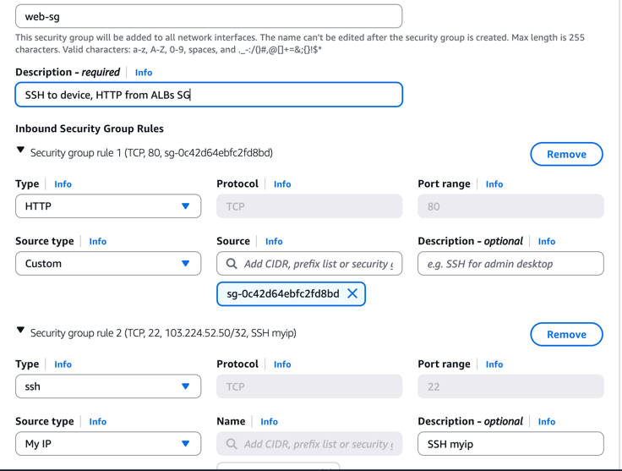

Figure: EC2’s Security configurations

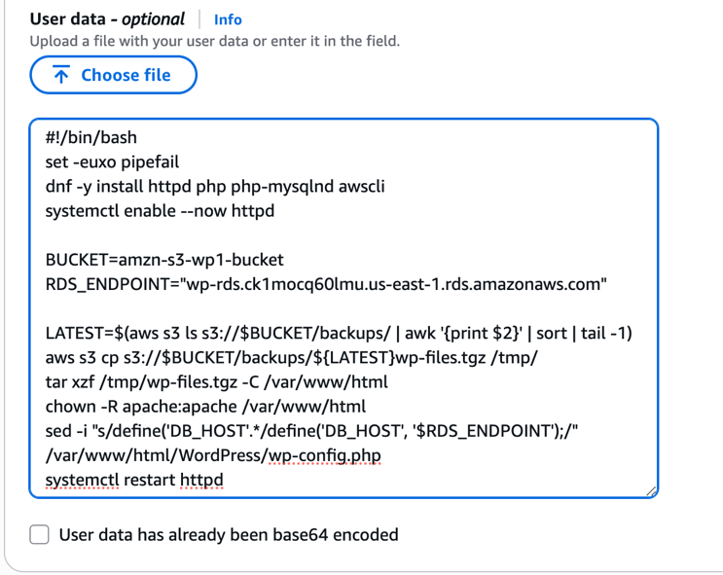

Figure: EC2’s User data

User data bash script for restoration justifications:

* Installs Apache web server (httpd), PHP (with MySQL extension), and AWS CLI.
* Enables and starts Apache so it runs immediately and on reboot.
* Defines variables:
* BUCKET = the S3 bucket storing backups.
* RDS_ENDPOINT = the hostname of RDS database.

Then:

* Lists folders inside *s3://amzn-s3-wp1-bucket/backups/*.
* Picks the latest backup folder by sorting and grabbing the last one.
* Downloads the latest WordPress backup archive (wp-files.tgz) from S3.
* Extracts it into Apache’s web root (/var/www/html).
* Ensures Apache owns the files (so it can serve and update them correctly).
* Updates the WordPress config file so it points to the RDS database instead of local MySQL.

And restart Apache to apply it.

Next, we register the new instance in existing Target Group wp-tg-http):

* Target groups → wp-tg-http → **Register targets** → add the new instance.

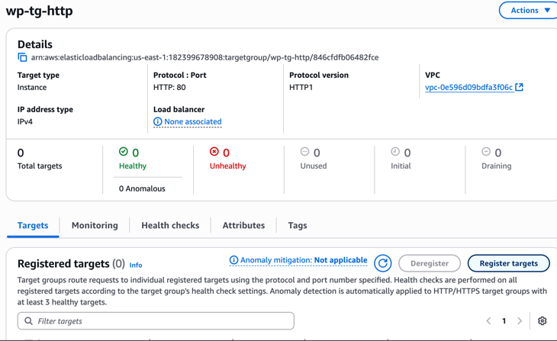

Figure: wp-tg-http

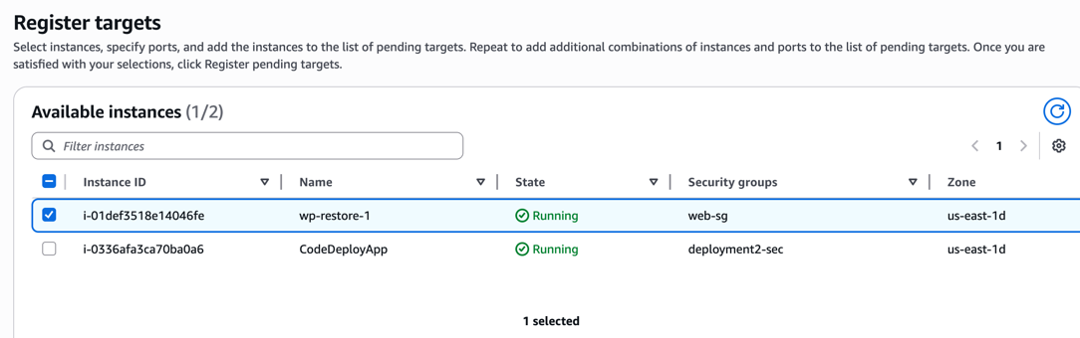

Figure: wp-tg-http register target

Now back to RDS’s security group rds-sg, we need to grant 3306 access to this new instance’s web-sg too, in order for it to connect with RDS’s db.

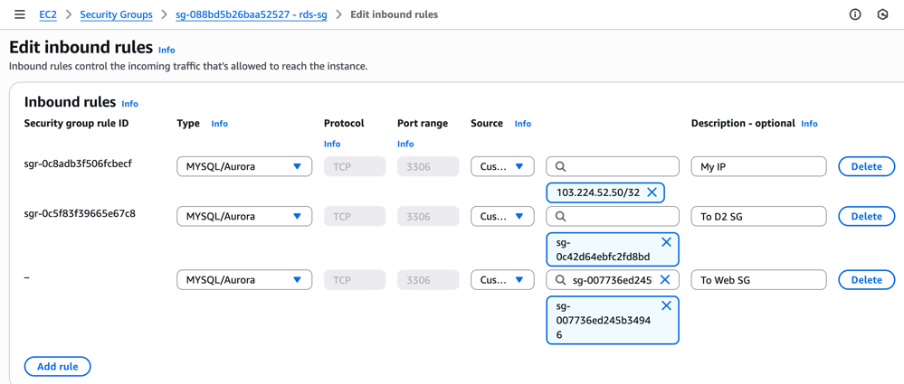

Figure: rds-sg inbound rule

Now the new instance can connect to RDS’s db.

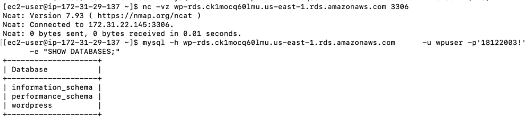

Figure: New EC2 connected to RDS

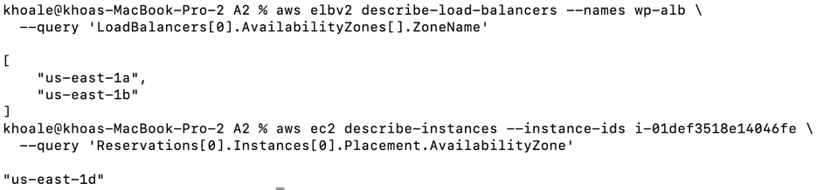

Figure: EC2 and ALB AZ’s mismatches

How ever, ALB public DNS can’t be reached, which the image above reason out, we used different AZ for ALB and the new instance, therefore, I recreate a new ALB at *us-east-1d* (and us-east-1a), name *wp-alb-2*. I also created new target group *wp-tg-http-2* linked to the new EC2. Both the ALB and Target group used similar setups to the original ones.

Now our WordPress app work on the new ALB’s public DNS:

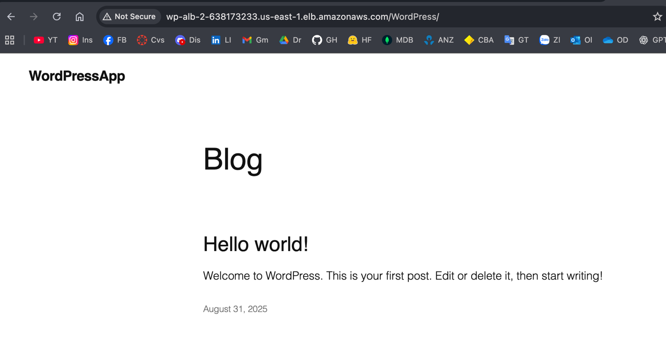

Figure: EC2 and ALB AZ’s mismatches

**2.3 Distinction: Create a Launch Template, ASG, configure ASG to launch instance, test scaling.**

**2.3.1 Create a Launch Template (restores from S3, points to RDS)**

**EC2 → Launch Templates → Create**

* Name: wp-lt-v1
* AMI: Amazon Linux 2023
* Instance type: t2.micro
* Key pair: deployment2-key
* **IAM instance profile**: (WPInstanceRole)
* Security group: web-sg (HTTP 80 from ALB SG)
* **User data**: same restore script as 2.2

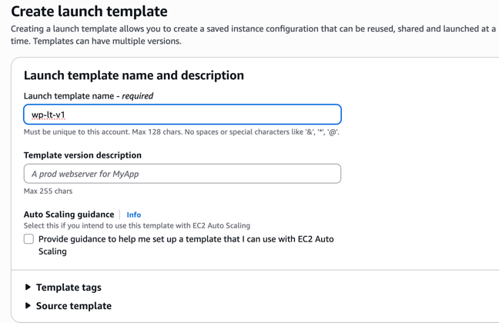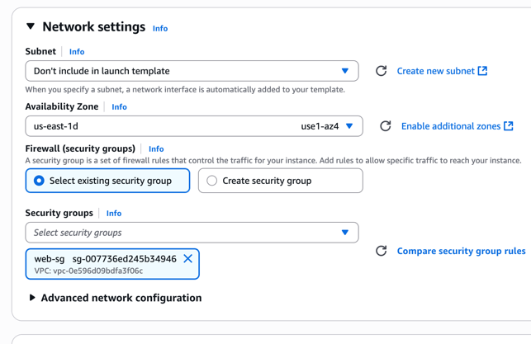

Figures. LT setups

**2.3.2 Create an Auto Scaling Group and attach to ALB**

**EC2 → Auto Scaling Groups → Create**

* Name: wp-asg
* Launch template: wp-lt-v1
* Subnets: at least two AZs
* Attach to **Target Group** wp-tg-http-2
* Desired capacity: **2**, Min: **1**, Max: **3**
* Health checks: **ELB** (Turn on Elastic Load Balancing health checks)
* Scaling policy: **Target tracking** → ASG Average CPU = **60%**

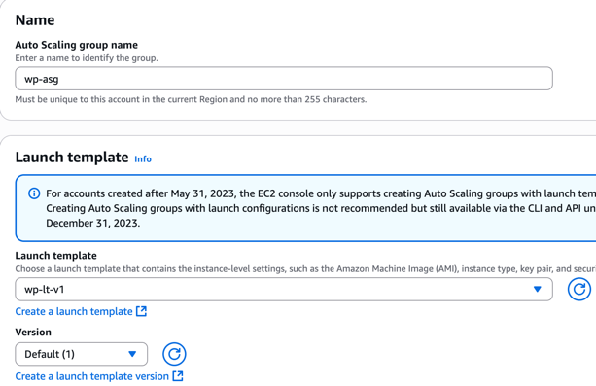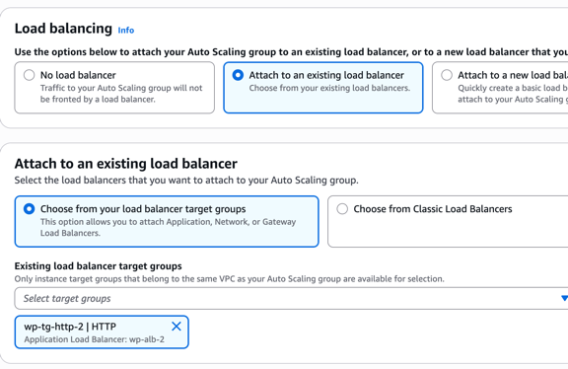

Figures. ASG setups

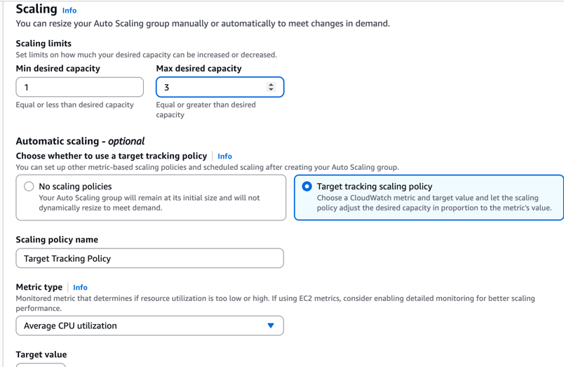

Figures. ASG Scaling

**2.3.3 Test scaling**

We run:

ab -n 3000 -c 50 http://<ALB-DNS>/WordPress/

Or specifically this to test the scaling:

ab -n 3000 -c 50 <http://wp-alb-2-638173233.us-east-1.elb.amazonaws.com/WordPress/>

From logs, after ~300 responses, the rest of the requests queued and then timed out → apr_pollset_poll: The timeout specified has expired.

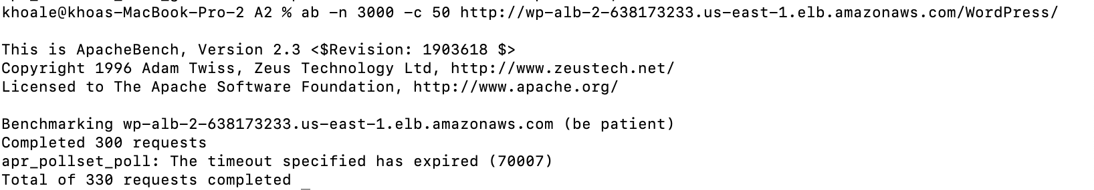

Figures. Test scaling

I SSH back to the new instance, and restart Apache, then try again, it’s healthy now:

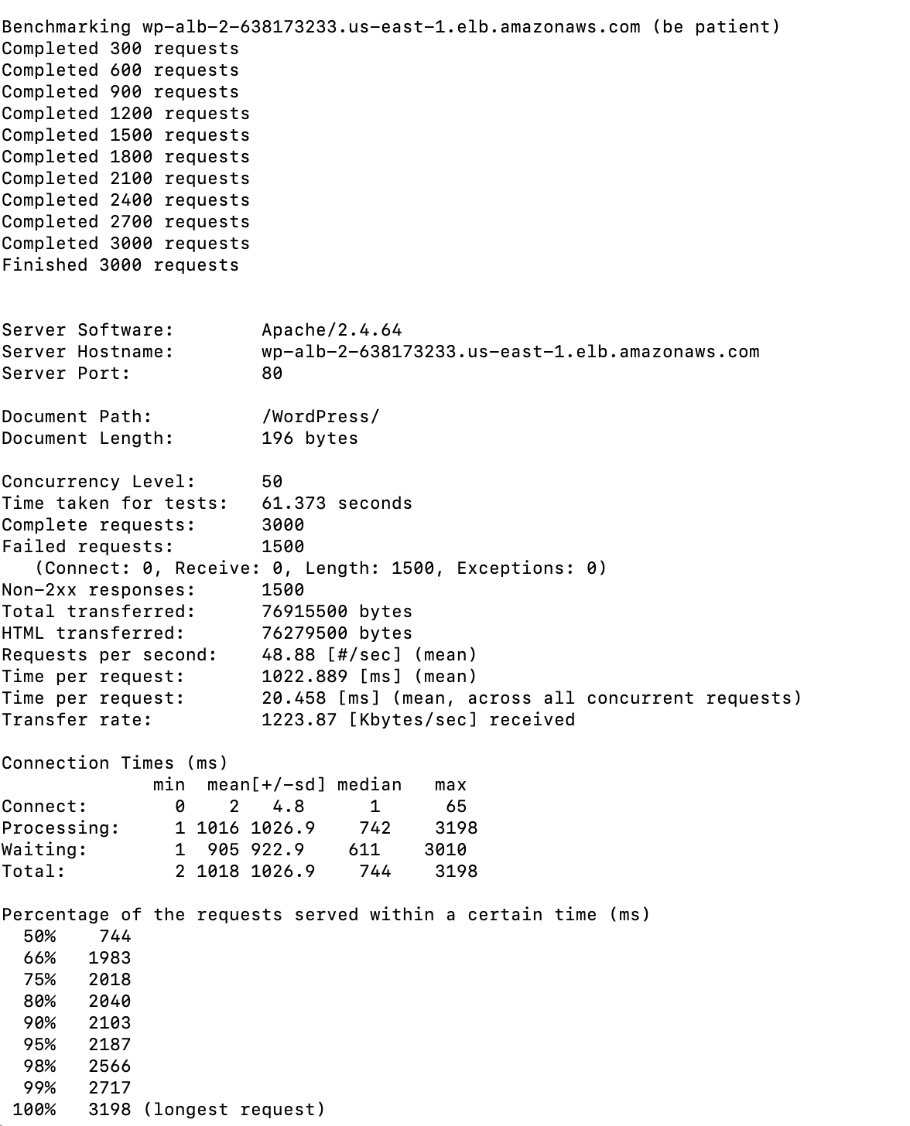

**Appendix**

What couldn’t work out for 2.1 Pass task, which I did this task on AWS Academy Learner Lab.

**2.1 Pass: Single EC2 WordPress - AWS Learner Lab**

**2.1.1 Preparation**

**Activating Learner Lab**

From the AWS account activation – invitation URL, I login with my student account, then navigate to Modules → AWS Academy Learner Lab → Launch AWS Academy Learner Lab.

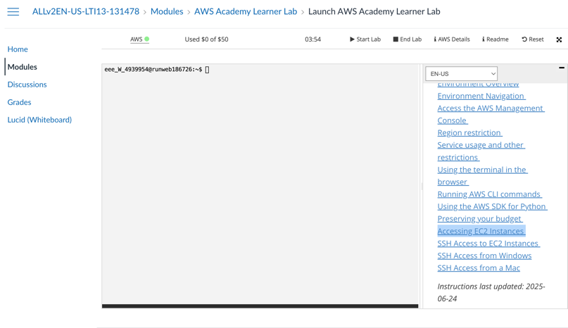

Figure. AWS Academy Learner Lab

Click Start Lab button, wait until the status on the left-hand side turn green, click onto it to navigate to AWS Console dashboard page. Click Start Lab button, wait until the status on the left-hand side turn green, which mean the lab has been activated.

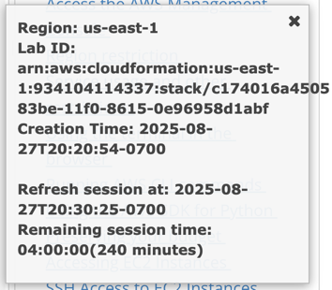

Figure. AWS Lab session information

Once the the status turn green, we can click to navigate to the AWS Console Dashboard page.

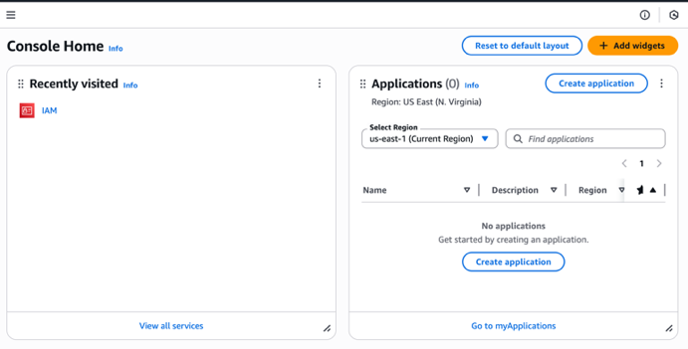

Figure. AWS Console page

**Console (UI)**

**Inspect IAM** **user:** At default, all student account on AWS Academy will have a default IAM user, however, I don’t have it. Student account cannot create an IAM user neither.

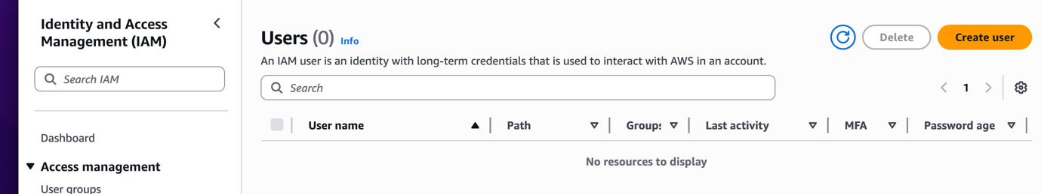

Figure. Empty IAM user at default

So later on I will just use a default “Select” option when creating my EC2 instance.

Other optional actions that could be considered/implemented in real-life deployment practices would be:

* **Create a Billing Budget**: Budgets → Create cost budget = **USD $10** with email alerts.
* **Create Project Tags**: For better multiple project management.

**2.1.2 EC2 Launching**

**A. Create SSH Key Pair**

We first will create a key pairs for later to SSH to EC2 instance.

Navigate to: EC2 → **Key pairs** → Create key pair → Name: deployment2-key → Type: **ED25519** → Download .pem (since I use MacOS, which .pem support it). After this, the .pem file will automatically downloaded to local device.



Figure. Create key pairs

**B. Create Security Group**

Then we need to create security group.

AWS security group to act as a virtual firewall, controlling all network traffic to and from Amazon Elastic Compute Cloud (EC2) instances. By defining specific inbound and outbound rules for ports, protocols, and IP addresses, security groups provide a crucial first layer of defense, allowing only necessary traffic to reach resources and protecting them from unauthorized access and potential threats.

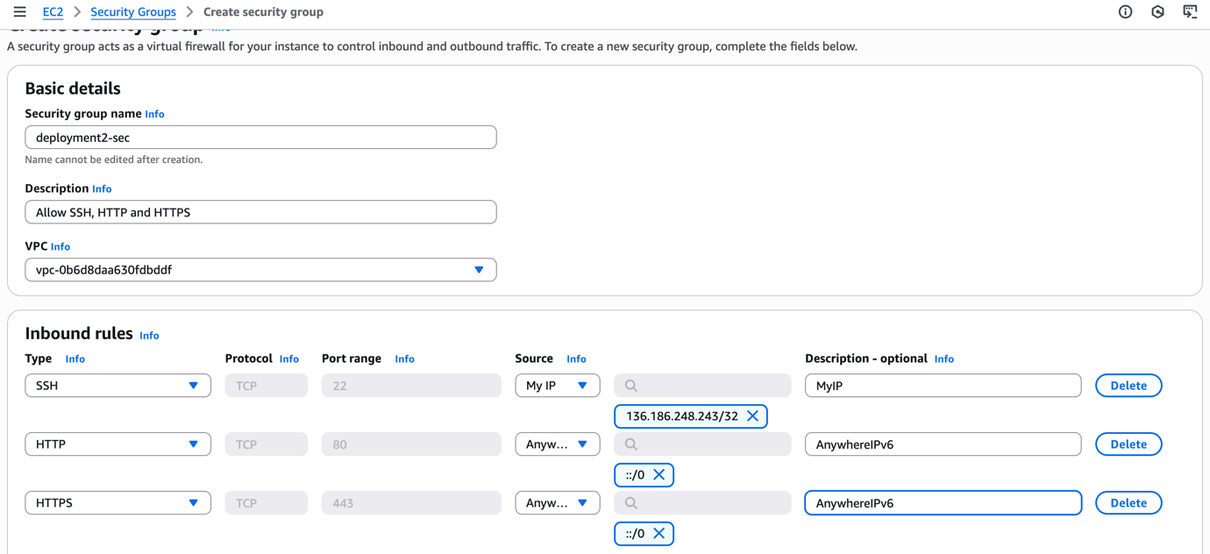

Figure. SG creation

I named the security group “deployment2-sec” with

Inbound rules: 22 (SSH, **My IP**) - To SSH to EC2 from local device

80 (HTTP, 0.0.0.0/0), - Allow everywhere access to HTTP port 80

443 (HTTPS, 0.0.0.0/0). - Allow everywhere access to HTTPS port 443 (Optional)

However, it’s worth mentioning that everywhere access to your server is not a good practice in real life deployment and should only be used for education and learning activities.

**C. Launch EC2, including Security Group (SG) and Key Pair**

We break this down to 4 steps

1. Navigate to EC2 → **Launch instance** → Name: “wordpress”.
2. **AMI: Amazon Linux 2023**, **Type: t3.micro.** These are default setup.
3. **Key pair:** deployment2-key, **SG:** deployment2-sec. These are our own key and SG.
4. Storage: 8 GB gp3. This is default setup



Figure. EC2 Setup - Step 1



Figure. EC2 Setup - Step 2



Figure. EC2 Setup - Step 3



Figure. EC2 Setup - Step 4

Then, we connect the EC2 instance, and remember their Public IP address (52.207.75.89) for SSH login.

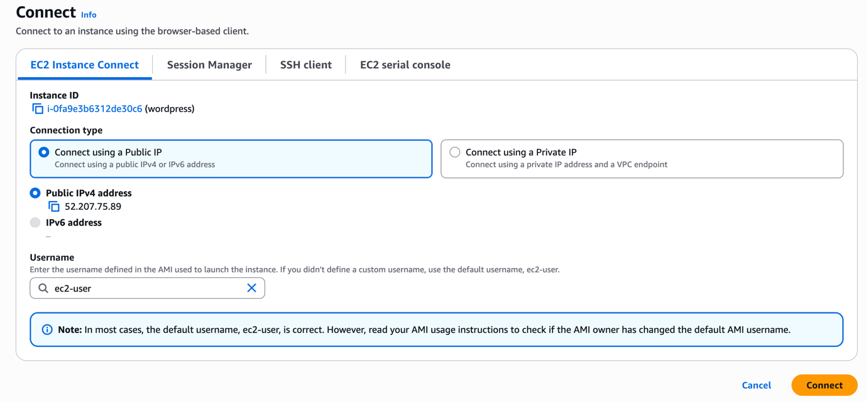

Figure. EC2 Connect

From here, we can directly access to our EC2 instance via CLI.

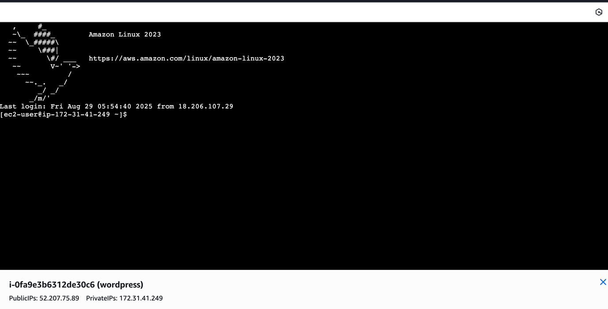

**D. SSH to EC2 (from local device)**

We will have to SSH to the EC2 instance via Command (Terminal) – AWS CLI:

At first, I ran this command: “ssh -i deployment2-key.pem ec2-user@52.207.75.89”. Which trigger SSH connection using the downloaded key, to the EC2 instance at destined public IP address we inspected earlier on EC2 Connect.

Note: the screenshot here was captured from previous ssh attempt, with a different EC2 instance.



Figure. SSH Warning

However, this was cancelled since we haven’t properly set permission to our key. The private SSH key is analogous to a password; if compromised, an attacker can gain unauthorized access to any system where the corresponding public key is deployed. Strict file permissions ensure that only the key's owner can read or modify it, preventing other users on the same system from accessing or copying it.



Figure. Set key permission

I set the permission with read-only rule to the owner (myself), which I can SSH again.

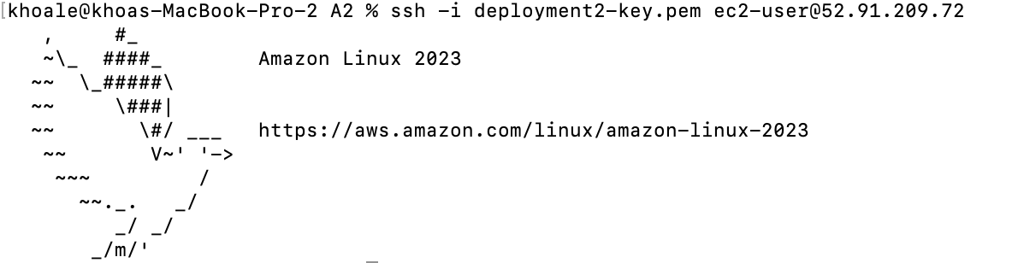

Figure. SSH Connection Successfully

**2.1.3 Installing WordPress on EC2 instance**

**A. Update Packages and install Apache, PHP and MariaDB (Optional):**

I ran the following CLI commands to update any packages and install Apache, PHP and MariaDB to my EC2:



Figure. Apache, PHP and MariaDB update and installation CLI commands

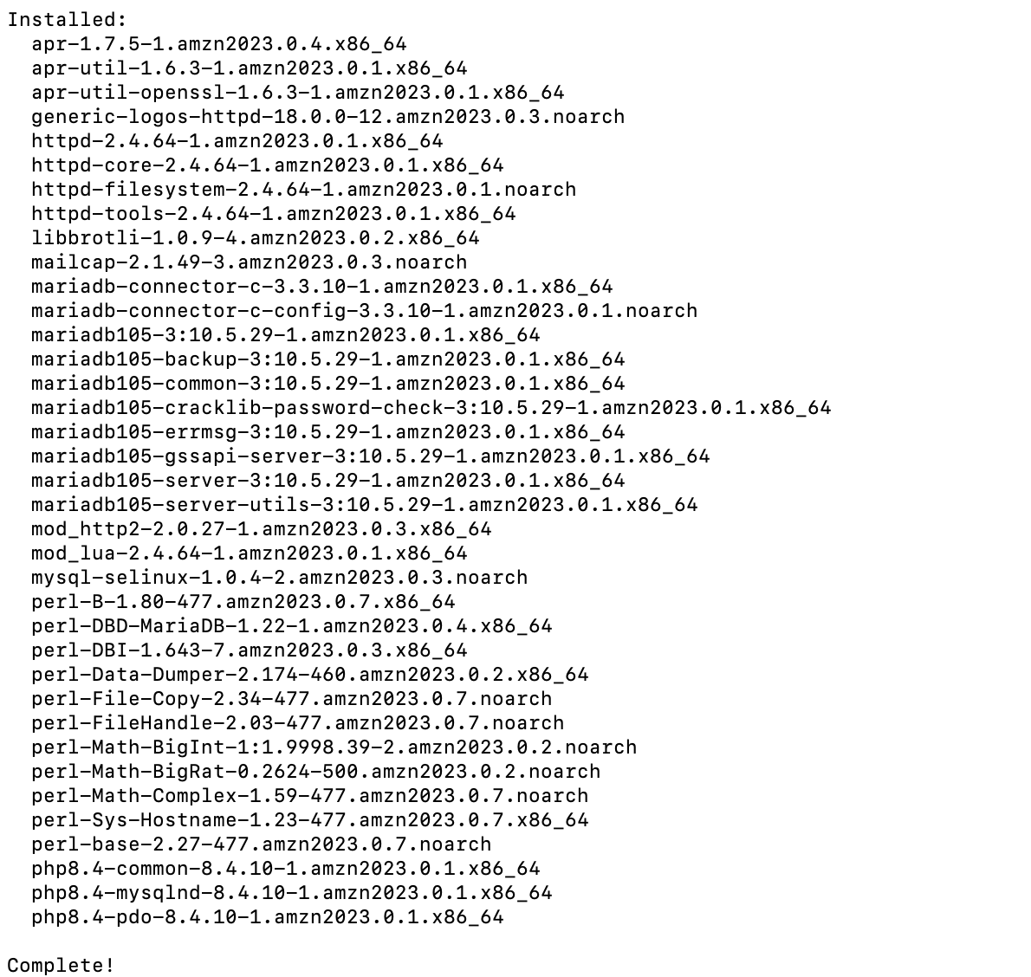

Figure. Terminal installation completed

**B. Start and enable Apache and MariaDB (Optional):**

The following CLI commands were executed to start and enable Apache:

sudo systemctl start httpd

sudo systemctl enable httpd

The following CLI commands were executed to start and enable Maria DB:

sudo systemctl start mariadb

sudo systemctl enable mariadb

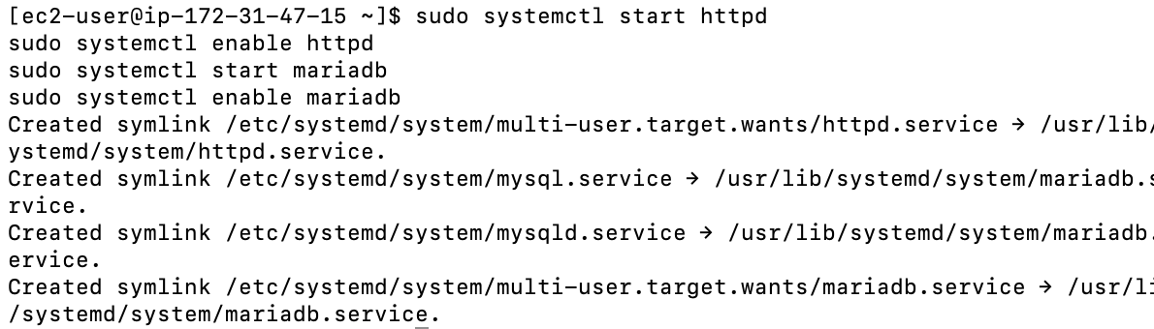

Figure. Terminal CLI start and enable completed

We can check for the status of any Apache HTTP services too, using the following command:

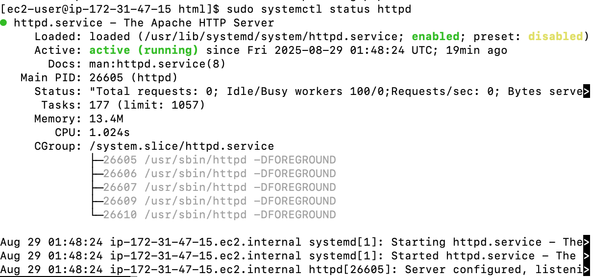

Figure. Apache http server status checker

**C. Download and unpack WordPress:**

I first Call the wget command to download a copy of the WordPress source code, as a .zip file, to the current directory:

wget <https://github.com/WordPress/WordPress/archive/master.zip>

The call the unzip, mkdir, cp, and rm commands to:

* Unpack the master .zip file into the /tmp/WordPress_Temp directory (folder).

unzip master -d /tmp/WordPress_Temp

* Copy its unzipped contents to the /tmp/WordPress destination folder.

mkdir -p /tmp/WordPress

cp -paf /tmp/WordPress_Temp/WordPress-master/* /tmp/WordPress

* Delete the temporary /tmp/WordPress_Temp folder and master file.

rm -rf /tmp/WordPress_Temp

rm -f master

Inspect /tmp folder again:



Figure. /tmp folder setup

**D. Create deployment scripts**

First I need to initiate the directory:

mkdir -p /tmp/WordPress/scripts

I can create these bash files using Nano tools:

**install_dependencies.sh** – installs PHP, Apache, MariaDB (or MySQL) and enables PHP support (previously done).

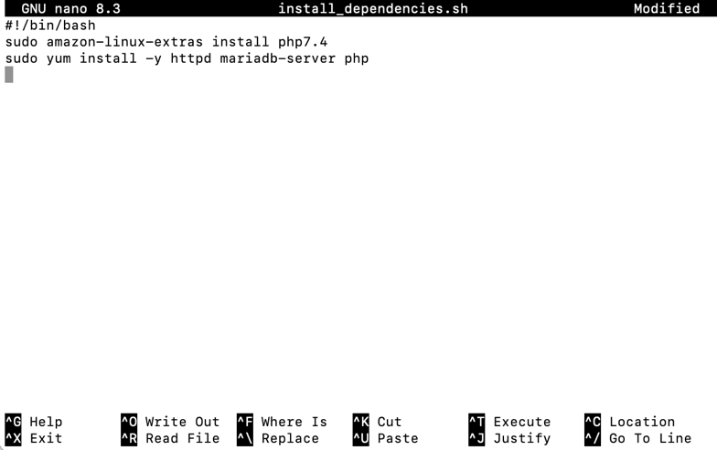

Figure. install_dependencies.sh

**start_server.sh** – starts HTTPD, MariaDB and PHP-FPM:

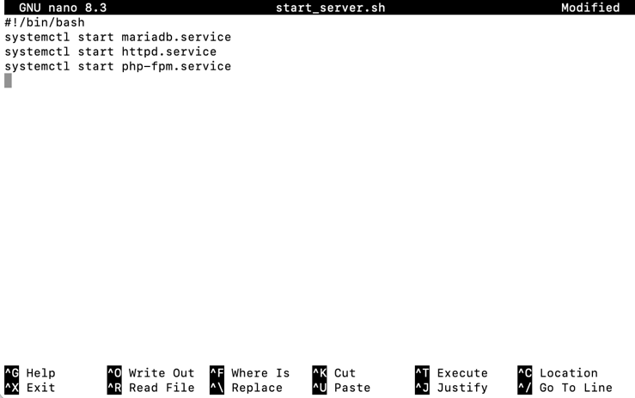

Figure. start_server.sh

**stop_server.sh** – stops them if running:

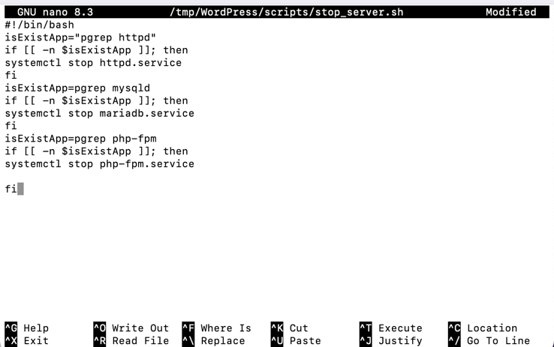

Figure. stop_server.sh

**create_wp_db.sh** – creates a database for our wordpress table:

1. CREATE DATABASE IF NOT EXISTS wordpress;

* This creates a new database named wordpress if not exist.
* It will hold all the tables WordPress needs (users, posts, settings, etc.).
* If we don’t run this, WordPress has nowhere to store its data

2. CREATE USER 'wpuser'@'localhost' IDENTIFIED BY 18122003!';

* This creates a new **database user account** called **wpuser**.
* The @'localhost' part means this user can only connect **from the same server (the EC2 instance itself)** — not from external machines.
* 18122003!' is my custom password for this user.

3. GRANT ALL PRIVILEGES ON wordpress.* TO 'wpuser'@'localhost';

* This gives the new user full privileges on all tables inside the **wordpress** database (wordpress.*).
* Privileges include SELECT (read), INSERT, UPDATE, DELETE, CREATE TABLE, etc.
* It does **not** give access to any other databases (e.g., mysql or sys).

4. FLUSH PRIVILEGES;

* This tells MariaDB/MySQL to reload the privilege table so changes take effect immediately.

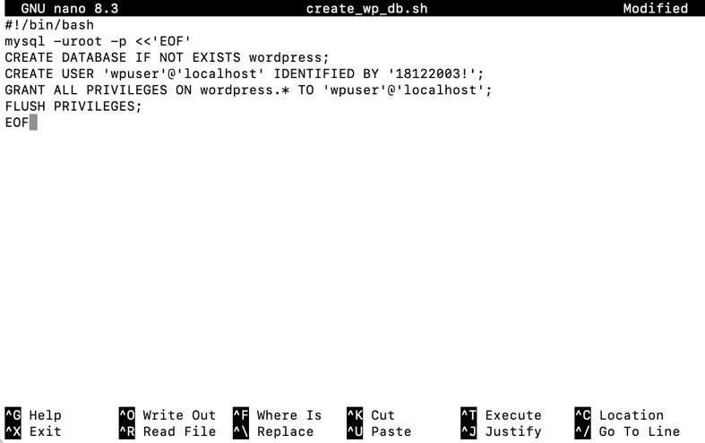

Figure. create_wp_db.sh

**change_permissions.sh** – temporarily relaxes permissions so WordPress can write to its own directory during configuration:

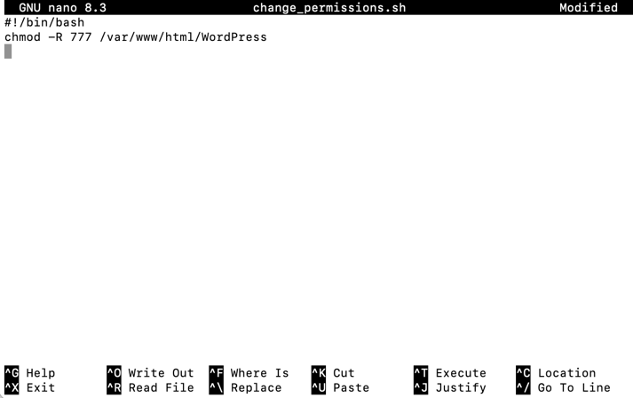

Figure. change_permissions.sh

After deploying and setting up WordPress, reset permissions with:

chmod -R 755 /var/www/html/WordPress

Make all deployment scripts executable:

chmod +x /tmp/WordPress/scripts/*

**Justifications:**

chmod -R 755 /var/www/html/WordPress:

* Sets **directories** to 755:
  + Owner (apache) = read/write/execute.
  + Group/others = read/execute only.
* The execute bit on directories means “can enter/list the directory.” Without it, Apache can’t traverse into directories to serve files.

These are good practices for security.

**E. Add an AppSpec file:**

We add an appspec.yml file to WordPress source (/tmp/WordPress) and tells the system (CodeDeploy) where to copy files and which scripts to run:

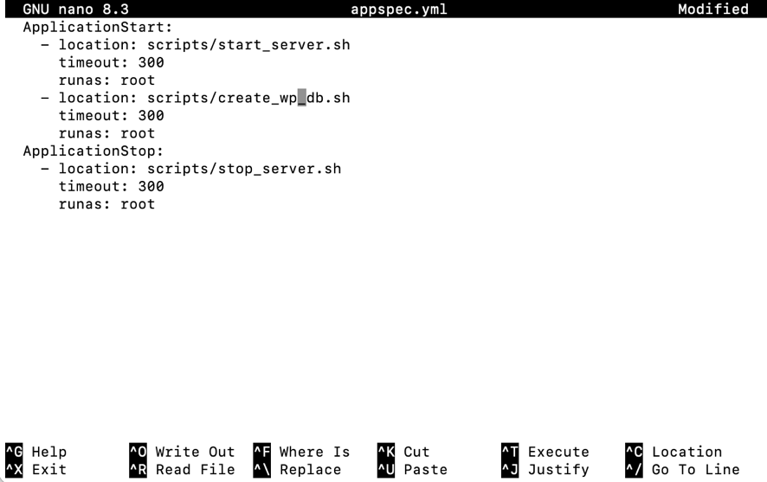

Figure. appspec.yml

CodeDeploy uses this file during deployment to orchestrate copying WordPress into the Apache root and calling the scripts in the right order.

**2.1.4 Provision an Amazon S3 bucket**

**A. Create a S3 Bucket**

We run this command to create a S3 bucket named “amzn-s3-wp-bucket” from CLI:

aws s3 mb s3://amzn-s3-wp-bucket --region region

Or go to Console UI at <https://us-east-1.console.aws.amazon.com/s3/>



Figure. Amazon S3 Dashboard

Proceed with Create bucket button, I created a bucket name “amzn-s3-wp-bucket”, all settings at default – Location: US East (N. Virginia) us-east-1.



Figure. Bucket name

**B. Grant the right permissions (bucket policy)**

* Go to the **S3 Console** → open this bucket (amzn-s3-wp-bucket).
* Click the **Permissions** tab.
* Scroll down to **Bucket policy** → **Edit**.
* Paste the JSON policy (upload permissions, instance role download permissions, optional hardening).
* Save changes.



Figure. Edit bucket policy

The S3 bucket policy contains **multiple statements**, each addressing a different actor and action:

1. **Uploader permissions (PutObject) - AllowUploaderToPut**

* Grants my AWS account (the root principal of the Academy lab account) permission to upload application revisions.
* Without this, the aws deploy push command or manual uploads would be blocked.
* Restricting the Resource to bucket/* ensures only **objects inside the bucket** can be written, not the bucket itself.

1. **CodeDeploy EC2 read permissions (GetObject) – AllowCodeDeployRoleToRead**

* Grants the **EC2 instance profile role** used by CodeDeploy the ability to fetch files (the WordPress ZIP bundle).
* Necessary during the deployment lifecycle, when the agent on the instance pulls the revision package from S3.
* Again scoped only to the object keys in this bucket.

1. **CodeDeploy EC2 role list permissions (ListBucket) – AllowCodeDeployRoleToList**

* Allows the same instance role to list object keys inside the bucket.
* This is essential because the CodeDeploy agent often needs to confirm the exact object key and revision version before fetching.
* Note that ListBucket is applied to the **bucket ARN only**, whereas GetObject applies to bucket/*.

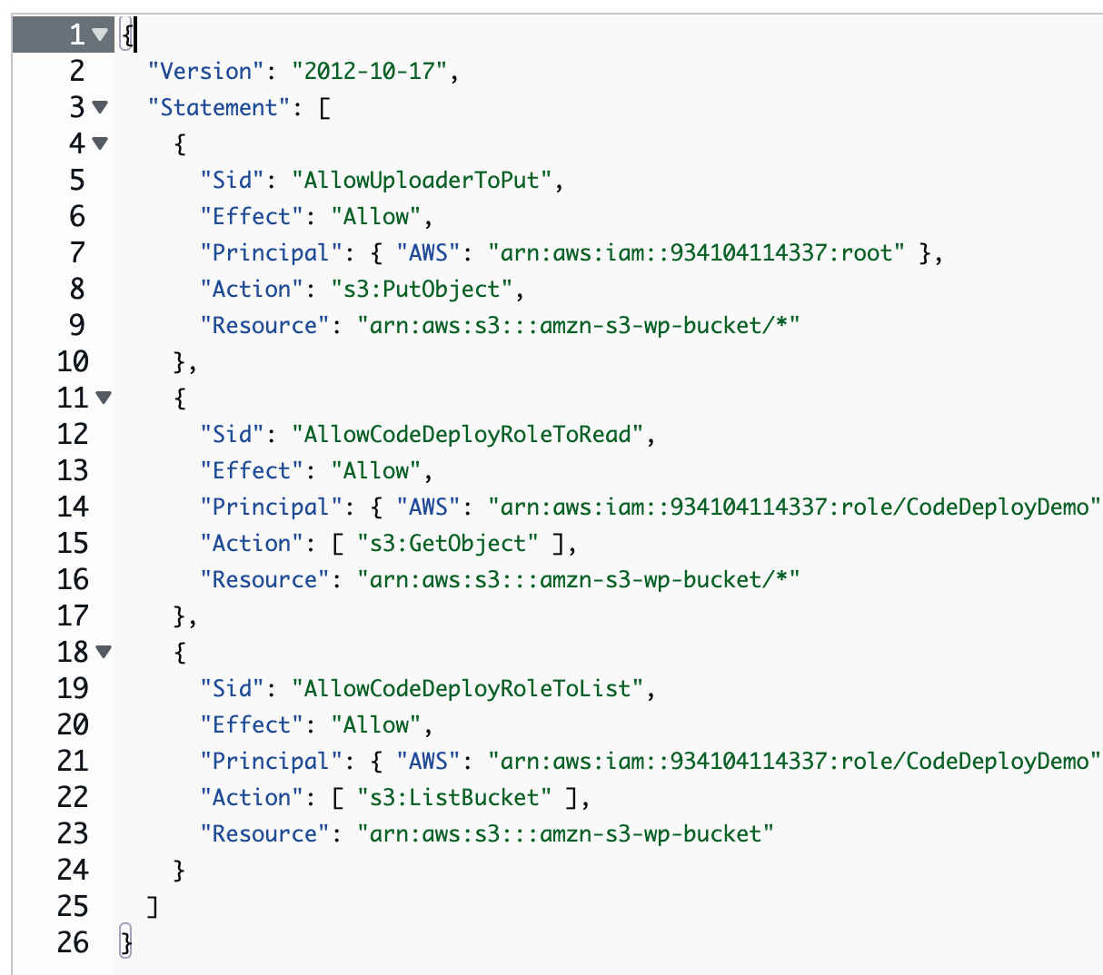

Figure. Bucket policy content

We couldn’t save the bucket policy since CodeDeployDemo/CodeDeploy isn’t our default IAM role like the tutorial:

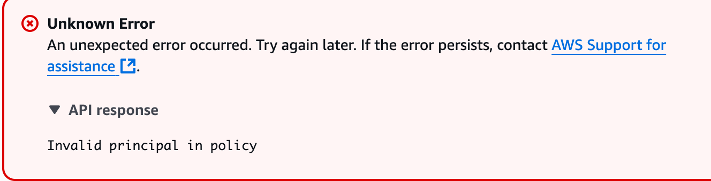

Figure. Bucket policy block

Hence, I persist same principles for all Statement as:

"Principal": { "AWS": "arn:aws:iam::934104114337:root" }

**C. Prepare and bundle the application folder and push to Amazon S3**





Figures. WordPress folder setup

We use ‘ls’ command to inspect our WordPress folder and it aligned with our tutorial

**D. Register the CodeDeploy application**

Create the CodeDeploy application:

We don’t have an IAM User for this account, that’s why this command to build/create the app couldn’t work.



Figures. CodeDeploy failure

So I came back to the Launch AWS Learner Lab page – AWS details to retrieve these AWS CLI information:

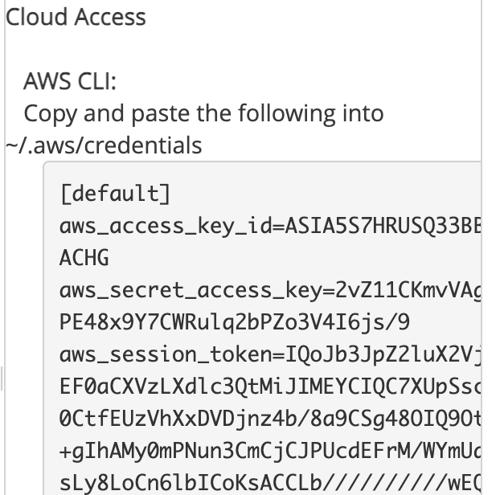

Figures. AWS CLI details

I then configure my account with Key ID and Secret key from AWS CLI details information: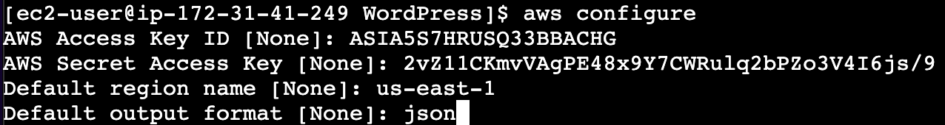

Figures. aws configure command and prompts

But still, that’s not working so I have to change this file too:

nano ~/.aws/credentials

I added my aws_session_token value there, save and reboot the application deployment command again:



Figures. WordPress_App build successfully

Now we can push the app to S3 with this command:

aws deploy push \

--application-name WordPress_App \

--s3-location s3://amzn-s3-wp-bucket/WordPressApp.zip \

--ignore-hidden-files

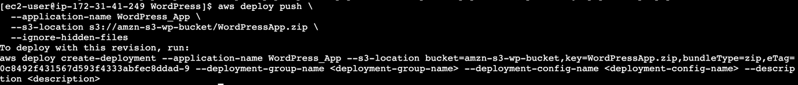

Figures. WordPress_App deployed successfully to S3

**2.1.5 Deploy application revision with CodeDeploy**

**A. Create Deployment Group**

For the first part, in order to create a Deployment Group (CLI), we need “service-role-arn” parameter as given in the tutorial, therefore, we cannot proceed with this, since we don’t have IAM User and cannot create IAM Role.

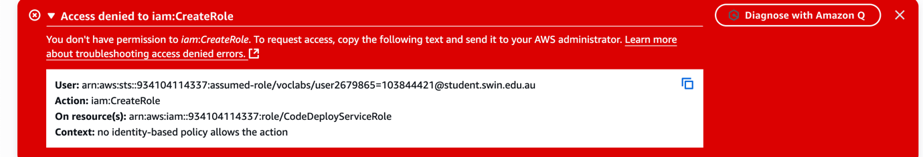

Figures. IAM Role creation denial

So I have I don’t have any role like CodeDeploy or CodeDeployDemo etc, so I have to use LabRole instead among a very few list of available IAM Role I have:



Figures. LabRole ARN

Before creating the deployment group, we need to create EC2 tag, such:

* Key: Name
* Value: CodeDeployDemo



Figures. Create EC2 tags

Then creating the deployment group with CLI, with a deployment group named WordPress_DepGroup:

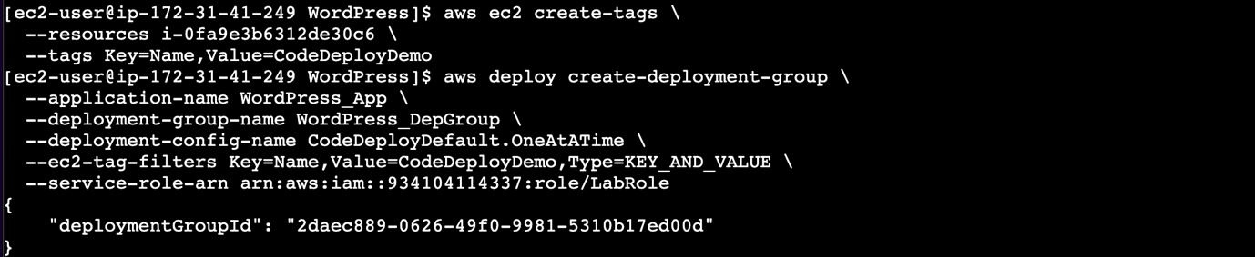

Figures. Create deployment group

**B. Deploy App Revision**

Before we create a deployment, the instances in the deployment group must have the CodeDeploy agent installed. We can install the agent from the command line with AWS Systems Manager by the following command:

aws ssm create-association \

--name AWS-ConfigureAWSPackage \

--targets Key=tag:Name,Values=CodeDeployDemo \

--parameters action=Install,name=AWSCodeDeployAgent \

--schedule-expression "cron(0 2 ? * SUN *)"

Now deploy the app revision with CLI, with the deployment group.

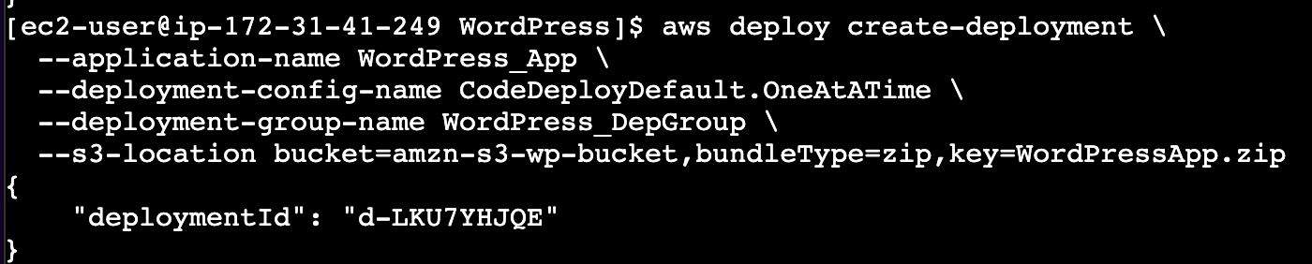

Figures. Deploy the app revision

Later, we can list all deployment for inspection with:

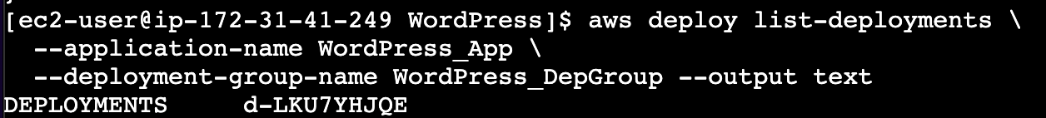

Figures. List deployment

And inspect any deployment’s status using the ID from the:

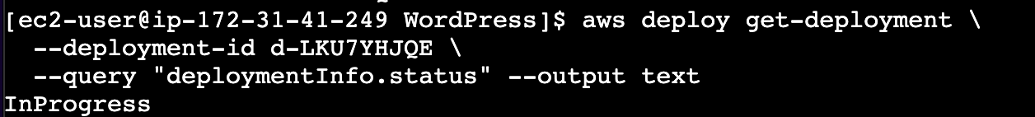

Figures. Inspect deployment status

Our deployment failed:

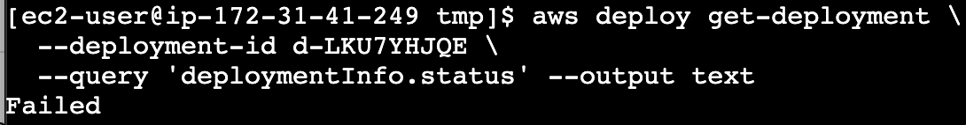

Upon reviewing, it is because it doesn’t have unit codedeploy-agent.service



We have to install the CodeDeploy agent on our instance (/tmp directory) and restart the agent upon startup:

sudo yum -y install ruby wget

REGION=us-east-1

cd /tmp

wget https://aws-codedeploy-$REGION.s3.$REGION.amazonaws.com/latest/install

chmod +x ./install

sudo ./install auto

sudo systemctl enable --now codedeploy-agent

sudo systemctl status codedeploy-agent --no-pager

So now I can use this command to review logs from CodeDeploy agent:

sudo tail -n 50 /var/log/aws/codedeploy-agent/codedeploy-agent.log

Error now shown as:

2025-08-29T09:10:00 ERROR [codedeploy-agent(3728)]: InstanceAgent::Plugins::CodeDeployPlugin::CommandPoller: Missing credentials - please check if this instance was started with an IAM instance profile

Which means

* The CodeDeploy agent is installed and running now.
* But when it tries to pull the revision from S3 (or talk to CodeDeploy APIs), it has no AWS credentials.
* CodeDeploy agents are designed to authenticate using the IAM instance profile attached to the EC2 instance.

I do not have an IAM role nor can create one, which return in empty result when listing this command:

aws sts get-caller-identity

Hence, I have to check the code-agent environment at:

/etc/codedeploy-agent/conf/codedeploy.onpremises.yml

And place in our details as earlier in part 2.1.4.D for temporary AWS CLI credentials information.

aws_access_key_id:

aws_secret_access_key:

aws_session_token:

region: us-east-1

Once done, we can restart the CodeDeploy agent again with:

sudo systemctl restart codedeploy-agent

The I recreate deployment which still Failed and then rerun the CodeDeploy logs again which show this now:

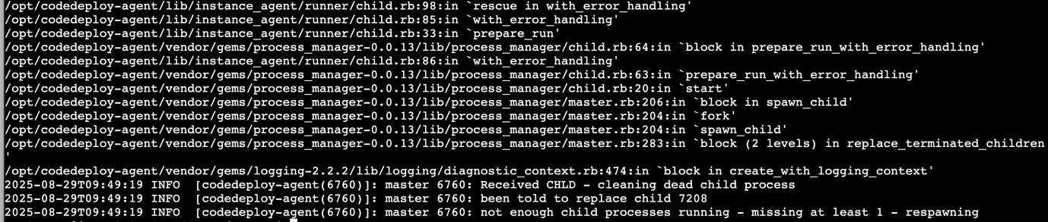

Figures. CodeDeploy fail with missing child process

That repeating **child process spawn → immediate exit → respawn** pattern still means the **CodeDeploy child runner is failing at startup**.

Because AWS Academy disables IAM role attachment for EC2 instances, the CodeDeploy agent cannot obtain instance profile credentials. This prevents full CodeDeploy-managed deployments.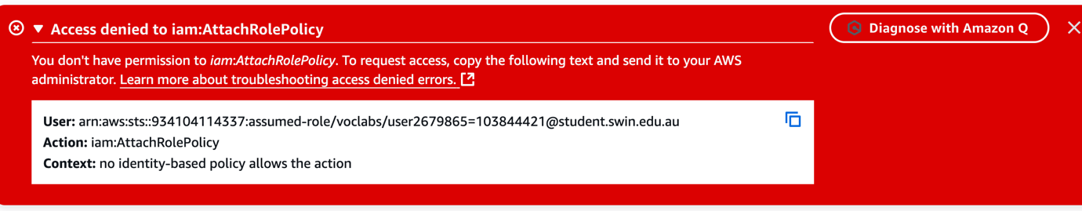

Figures. Failed to attach CodeDeploy permission to LabRole

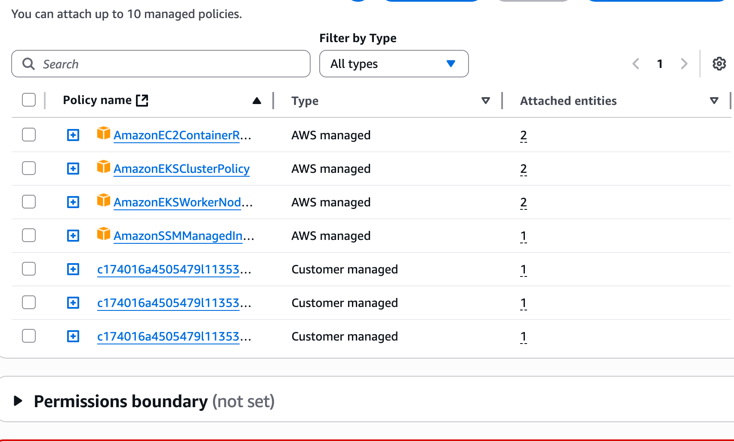

Figures. Current permissions for LabRole

**C. Workaround**

Because my AWS account prevents full CodeDeploy-managed deployments. As a workaround, application bundles were uploaded to S3 and then manually deployed onto EC2 instances for verification.”

**1. Ensure Apache (httpd) is running on the instance.**

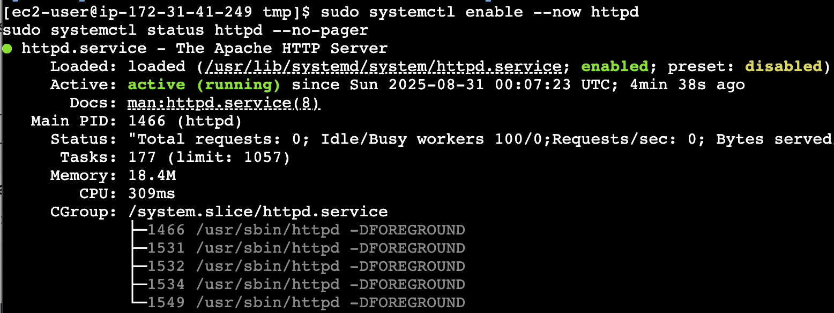

Figure. Ensure Apache is running

We ran the following 2 command to ensure httpd is running

sudo systemctl enable --now httpd

sudo systemctl status httpd --no-pager

**2. WordPress exists under the Apache web root.**

We re-download the WordPress zip file that earlier pushed to S3, back to our EC2, unzip and move to /var/www/html/ path (default Apache web root), then grant access to it:

aws s3 cp s3://amzn-s3-wp-bucket/WordPressApp.zip /tmp/

sudo unzip /tmp/WordPressApp.zip -d /var/www/html/

sudo chown -R apache:apache /var/www/html

**3. Verifying instance**

We run this command to verify EC2 instance state and inspect its public DNS, which is shown as:

*ec2-54-88-221-144.compute-1.amazonaws.com*

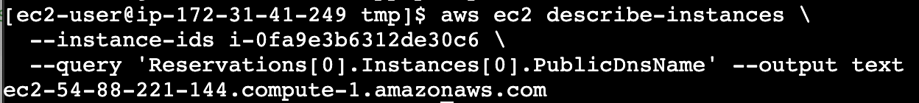

Figure. Describe instance

Check our DNS direct access from web browser, which show it’s working:

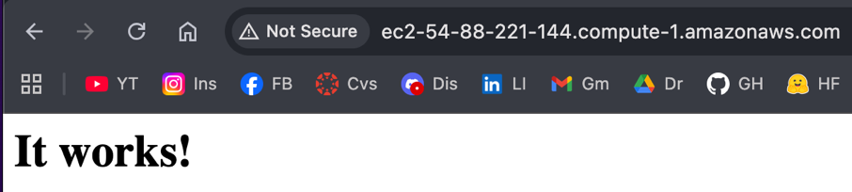

Figure. Check instance httpd on browser

Then we also inspect the /WordPress/ page, which do list out our files correctly.

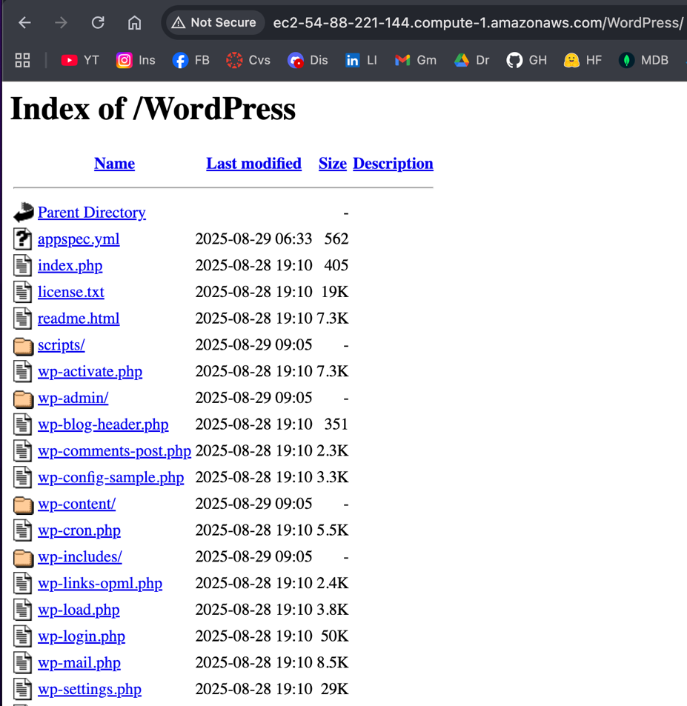

Figure. Check WordPress app on browser

Apparently:

* Apache doesn’t have **PHP handler / module** enabled, or
* The Apache configuration isn’t set to treat index.php as a default index file.

**4. Verifying modules**

So then, we need to verify these modules are properly installed and enabled, with CLI commands for executions:

* Ensure PHP & Apache modules are installed:

sudo dnf -y install php php-mysqlnd php-fpm

* Enable PHP module in Apache

sudo dnf -y install php-cli php-common php-devel php-mbstring php-xml

sudo systemctl restart httpd

* Update Apache to prioritize index.php

We check for: */etc/httpd/conf/httpd.conf* file, at default, it is set to only prioritise index.html with:

DirectoryIndex index.html

We used nano to edit the file prioritising index.php as default.

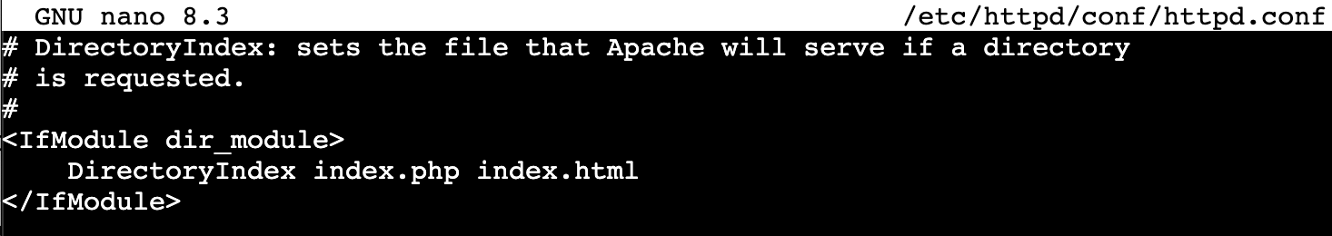

Figure. /etc/httpd/conf/httpd.conf

Then we restart Apache again:

sudo systemctl restart httpd

Now access WordPress from our public DNS with the previous link, our WordPress webapp is shown properly.

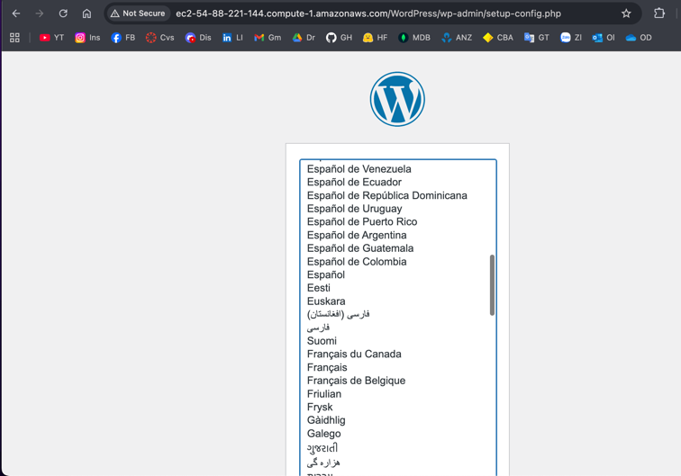

Figure. WordPress app setup page on browser

Then we will prompted for the database connection page:



Figure. WordPress app Database connection page

We fill in database details as earlier configured in *create_wp_db.sh.*



Figure. WordPress database configs

We are now featured this error screen when submitting, this screen means WordPress **couldn’t write** *wp-config.php* automatically (common when Apache doesn’t have write access). I will need to create it manually.

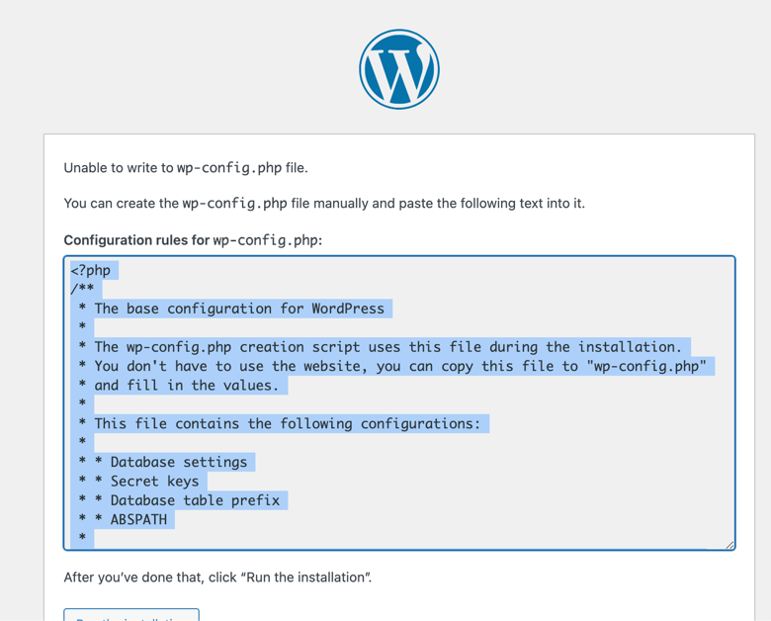

Figure. WordPress database error

I will use Nano to edit WordPress app configs file at */var/www/html/WordPress/wp-config.php*.

We first need to create a unique phrase (secret key) first, which tool can be found on WordPress website via: <https://api.wordpress.org/secret-key/1.1/salt/>

I then define the WordPress database’s name, MySQL username, password, host and preferences for charset and Collate. Next I defines all secrets as created in WordPress website generator tool.

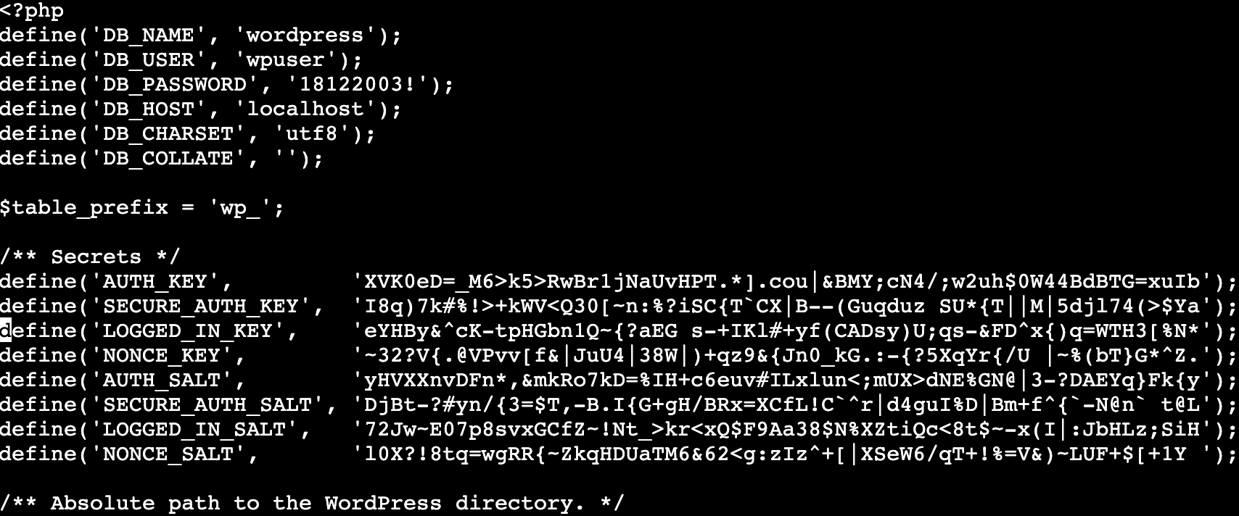

Figure. wp-config.php

Absolute path, variables and files included in WordPress app also defined.

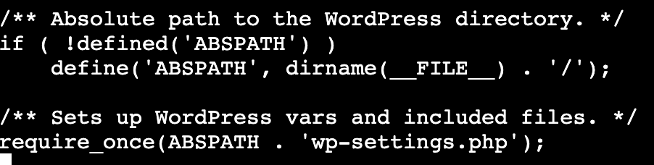

Figure. wp-config.php

Set proper ownership so Apache can read it (owner can read and write):

sudo chown apache:apache wp-config.php

sudo chmod 644 wp-config.php

Once we refresh our browser, the WordPress app now prompt us to fill in information for the final step before installation (I used the default password bB%sRd6tE&t9bwfQsr):

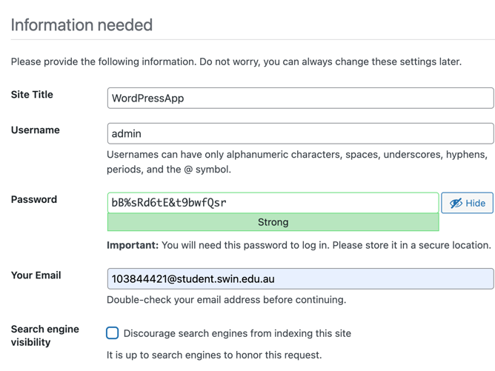

Figure. WordPress information page

Once installed, we can login.

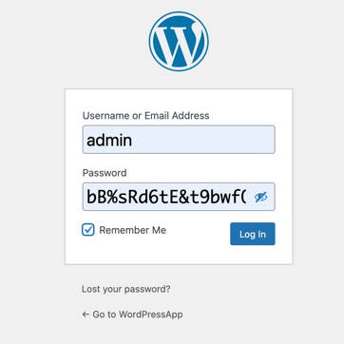

Figure. WordPress login page

Now the app is finalised.

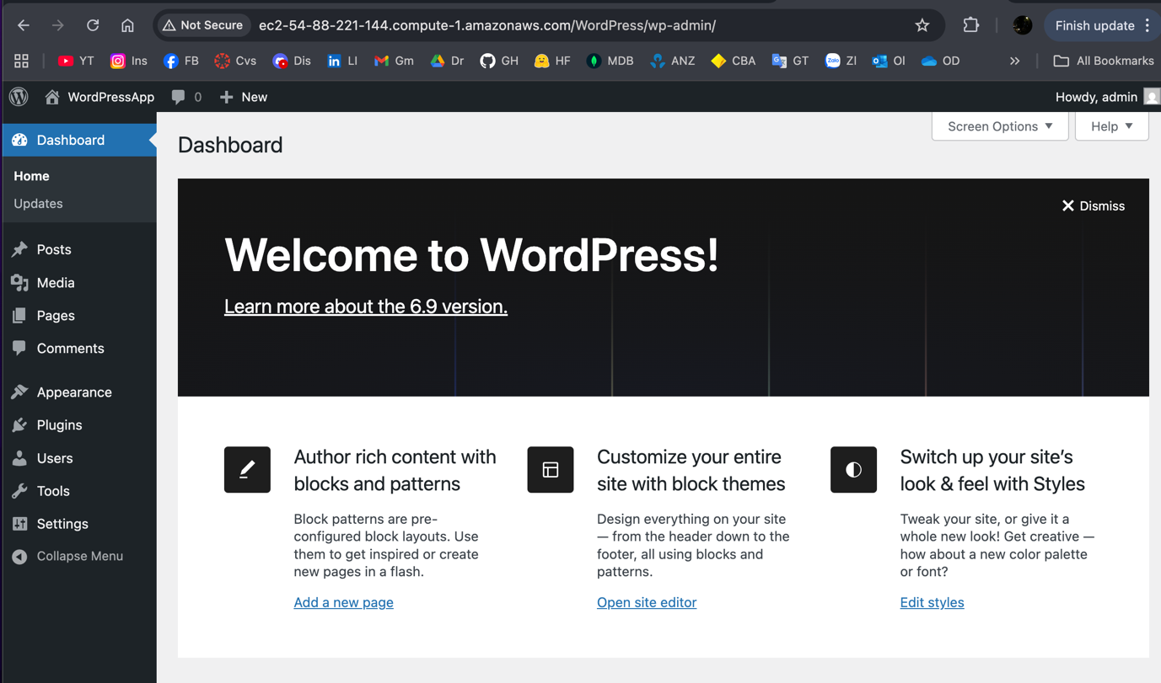

Figure. WordPress app working